







USING



* Kaushik Umesh Patil

001056490

**Technologies Used**

1. Hadoop MapReduce



1. Apache Hive



1. Apache Pig



1. Tableau



**Dataset**

**Dataset Link ->** <https://s3.amazonaws.com/amazon-reviews-pds/tsv/amazon_reviews_us_Sports_v1_00.tsv.gz>

The data is Amazon Sports available in TSV files in the amazon-reviews-pdf S3 bucket in AWS US East Region. Each line in the data files corresponds to an individual review (tab delimited, with no quote and escape characters).

**marketplace** - 2 letter country code of the marketplace where the review was written.

**customer_id** - Random identifier that can be used to aggregate reviews written by a single author.

**review_id** - The unique ID of the review.

**product_id** - The unique Product ID the review pertains to. In the multilingual dataset the reviews for the same product in different countries can be grouped by the same product_id.

**product_parent** - Random identifier that can be used to aggregate reviews for the same product.

**product_title** - Title of the product.

**product_category** - Broad product category that can be used to group reviews(also used to group the dataset into coherent parts).

**star_rating** - The 1-5 spelter rating of the review.

**helpful_votes** - Number of helpful votes.

**total_votes** - Number of total votes the review received.

**vine** - Review was written as part of the Vine program.

**verified_purchase** - The review is on a verified purchase.

**review_headline** - The title of the review.

**review_body** - The review text.

**review_date** - The date the review was written.

**Dataset Screenshots**

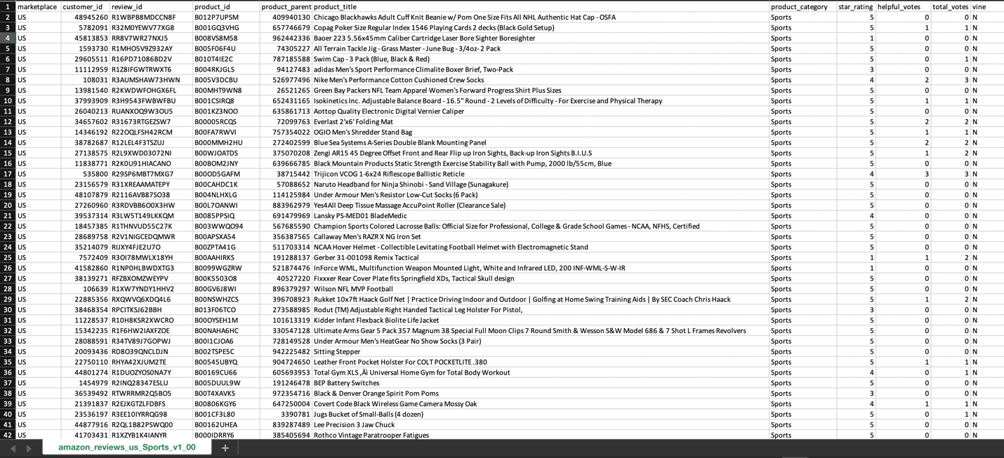

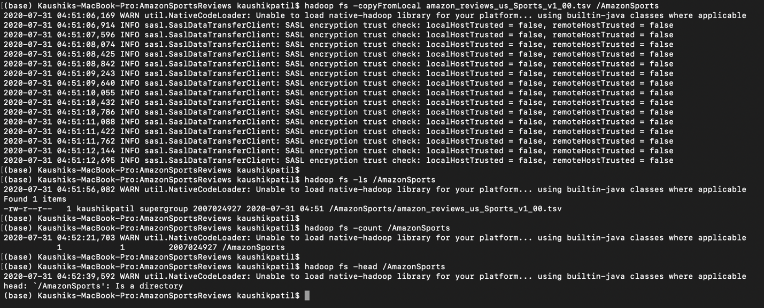

hadoop fs -copyFromLocal amazon_reviews_us_Sports_v1_00.tsv /AmazonSports

hadoop fs -ls /AmazonSports

**The Big Data Analysis of Amazon Sports Review will be done using Hadoop MapReduce, Apache Hive and Apache Pig and Tableau.**

**MapReduce:** It is the core component for data processing in Hadoop framework. In layman’s term MapReduce helps to split the input data set into a number of parts and run a program on all data parts parallel at once. The term MapReduce refers to two separate and distinct tasks. The first is the map operation, takes a set of data and converts it into another set of data, where individual elements are broken down into tuples (key/value pairs). The reduce operation combines those data tuples based on the key and accordingly modifies the value of the key.

**Apache Hive:** It is a platform used to develop SQL type scripts to do MapReduce operations.

**Apache Pig:** It is a procedural language platform used to develop a script for MapReduce operations.

**Tableau:** Tableau is the fastest growing data visualization tool that aims to help people see and understand data. In other words, it simply converts raw data into a very easily understandable format.

**Deliverables**

**Total 15+ unique operations achieved.**

**Hadoop**

1. **Overall Average Rating of all Products (Basic MapReduce)**
2. **Average Rating of all Products based on the Year (SecondorySorting Technique)**
3. **Number of Products per Rating (Counter using Numerical Summarization Pattern)**
4. **Segregation of all Products based on their rating (Binning Organization Pattern)**
5. **Top 25 Best Products based on average ratings (Filtering Pattern and Job Chaining)**
6. **List of customers for each product who have given review (Distinct or Inverted Index Pattern)**
7. **Legit Customer Review Analysis (Numerical Summarization Pattern)**
8. **Average of ratings and list of customers reviewed (Using Inner Join)**
9. **Amazon Word Count**

**Hive**

1. **Top 10 Best Products based on average ratings**
2. **Top 3 Customer based on the number of products**
3. **Top 3 Popular Product based on number of products sold**
4. **Number of products sold per day**
5. **Number of products per rating**

**Pig**

1. **Count of Daily Reviews**
2. **Reviews per Rating**

**Hadoop**

**Overall Average Rating of all Products (Basic MapReduce)**

I have started the project with basic MapReduce for calculating overall average rating for all products.

It will show how many times the rating has been given to a product and its average rating along with product title.

There are two writable – ProductsWritable (Details of the products) and AverageCountWritable (Average and Count values).

**Outputs**

hadoop jar 1.OverallAverageRating-1.0-SNAPSHOT.jar com.neu.edu.overallrating.Driver /AmazonSports/amazon_reviews_us_Sports_v1_00.tsv /AmazonSports/Part1/result1

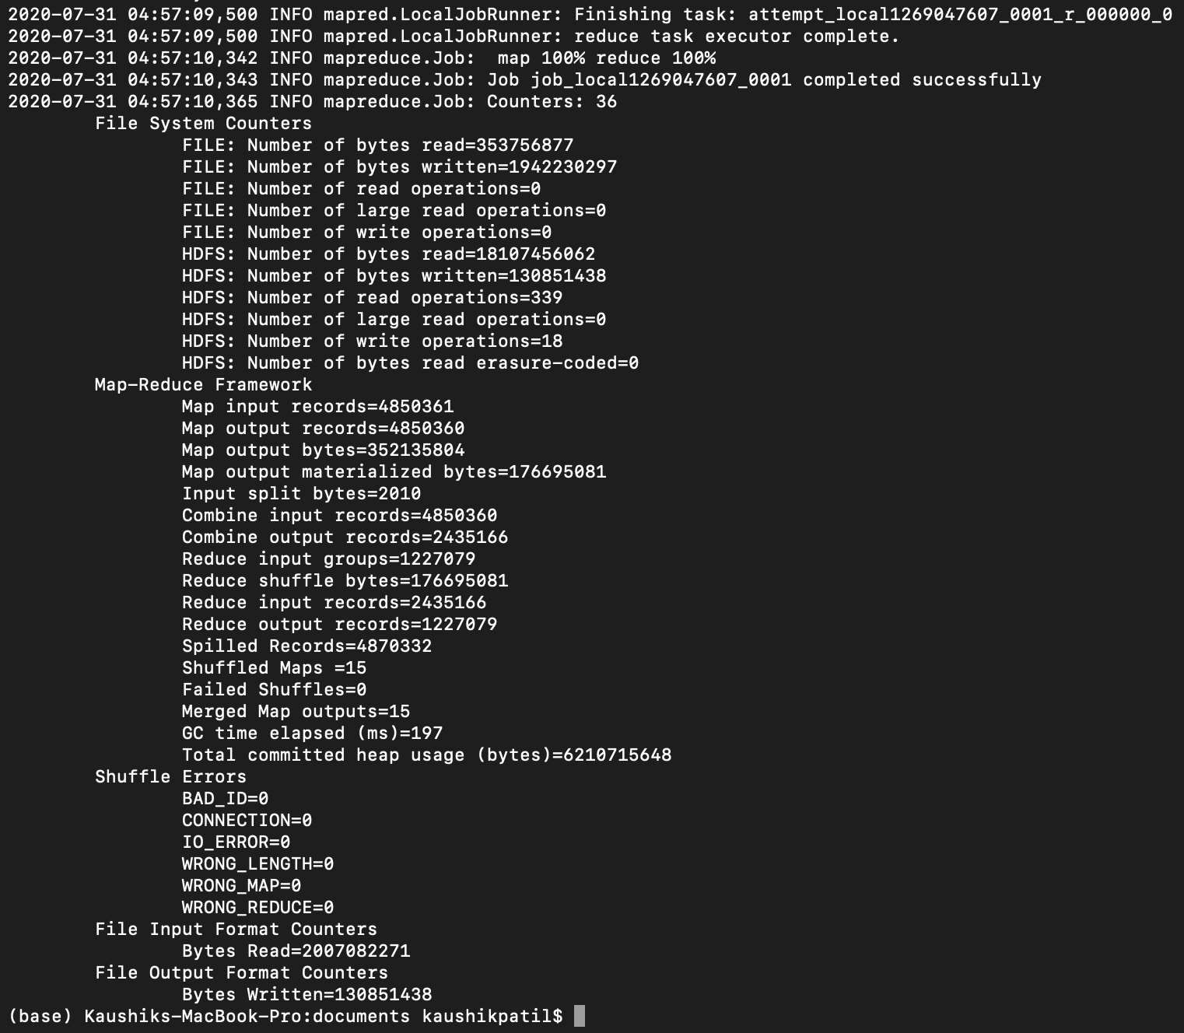

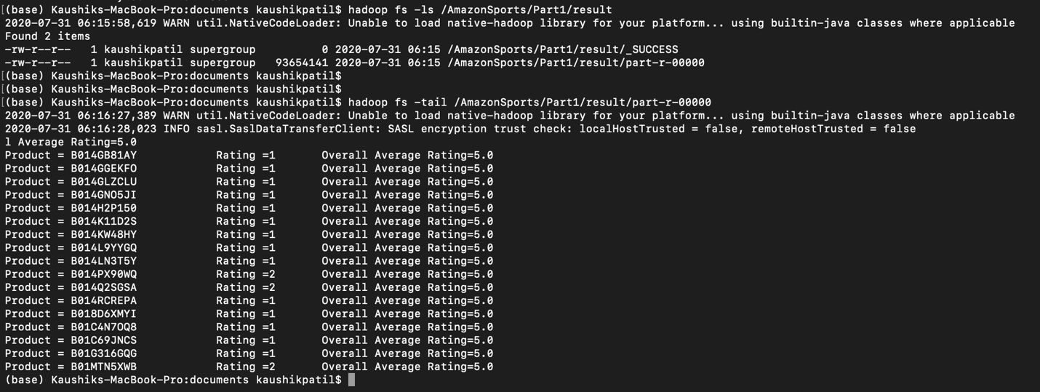

**Code**

**RatingMapper**

package com.neu.edu.overallrating;

import java.io.IOException;

import org.apache.hadoop.io.*;

import org.apache.hadoop.io.Text;

import org.apache.hadoop.mapreduce.Mapper;

/**

*

* @author kaushikpatil

*/

public class RatingMapper extends Mapper <Object, Text, ProductsWritable, AverageCountWritable> {

private ProductsWritable productsWritable = new ProductsWritable();

private AverageCountWritable averageCountWritable = new AverageCountWritable();

public void map(Object key, Text value, Context context) throws IOException, InterruptedException {

String[] values = value.toString().split("\t");

if(values[3] != null && values[7] != null && !values[0].equals("marketplace")) {

String productID = values[3];

float productRating = Float.parseFloat(values[7]);

productsWritable.setProductsSymbol(productID);

productsWritable.setratings(productRating);

averageCountWritable.setCount(1);

averageCountWritable.setRatingAvg(productRating);

context.write(productsWritable, averageCountWritable);

}

}

}

**RatingReducer**

package com.neu.edu.overallrating;

import java.io.IOException;

import org.apache.hadoop.io.Text;

import org.apache.hadoop.mapreduce.Reducer;

/**

*

* @author kaushikpatil

*/

public class RatingReducer extends Reducer <ProductsWritable, AverageCountWritable, ProductsWritable, AverageCountWritable> {

private AverageCountWritable res = new AverageCountWritable();

public void reduce(ProductsWritable key, Iterable <AverageCountWritable> values, Context context) throws IOException, InterruptedException {

float sum = 0;

int count = 0;

for(AverageCountWritable val: values) {

sum += val.getCount() * val.getRatingAvg();

count += val.getCount();

}

res.setCount(count);

res.setRatingAvg(sum/count);

context.write(key, res);

}

}

**Driver**

package com.neu.edu.overallrating;

import org.apache.hadoop.conf.Configuration;

import org.apache.hadoop.fs.FileSystem;

import org.apache.hadoop.fs.Path;

import org.apache.hadoop.mapreduce.Job;

import org.apache.hadoop.mapreduce.lib.input.FileInputFormat;

import org.apache.hadoop.mapreduce.lib.input.TextInputFormat;

import org.apache.hadoop.mapreduce.lib.output.FileOutputFormat;

/**

*

* @author kaushikpatil

*/

public class Driver {

public static void main(String[] args) throws Exception{

Path inputPath = new Path(args[0]);

Path outputDir = new Path(args[1]);

Configuration conf = new Configuration();

Job job = Job.getInstance(conf);

job.setJarByClass(RatingMapper.class);

job.setPartitionerClass(AveragePartitioner.class);

job.setMapperClass(RatingMapper.class);

job.setReducerClass(RatingReducer.class);

job.setCombinerClass(RatingReducer.class);

job.setNumReduceTasks(1);

job.setMapOutputKeyClass(ProductsWritable.class);

job.setMapOutputValueClass(AverageCountWritable.class);

job.setOutputKeyClass(ProductsWritable.class);

job.setOutputValueClass(AverageCountWritable.class);

FileInputFormat.addInputPath(job, inputPath);

job.setInputFormatClass(TextInputFormat.class);

FileOutputFormat.setOutputPath(job, outputDir);

FileSystem hdfs = FileSystem.get(conf);

if (hdfs.exists(outputDir)){

hdfs.delete(outputDir, true);

}

int code = job.waitForCompletion(true) ? 0 : 1;

System.exit(code);

}

}

**ProductsWritable**

package com.neu.edu.overallrating;

import java.io.DataInput;

import java.io.DataOutput;

import java.io.IOException;

import org.apache.hadoop.io.Writable;

import org.apache.hadoop.io.WritableComparable;

/**

*

* @author kaushikpatil

*/

public class ProductsWritable implements Writable, WritableComparable<ProductsWritable>{

private String productID;

private float ratings;

public ProductsWritable() {

super();

}

public ProductsWritable(String ProductsSymbol, float ratings) {

super();

this.ratings = ratings;

this.productID = ProductsSymbol;

}

public String getProductsSymbol() {

return productID;

}

public void setProductsSymbol(String ProductsSymbol) {

this.productID = ProductsSymbol;

}

public float getrating() {

return ratings;

}

public void setratings(float ratings) {

this.ratings = ratings;

}

@Override

public int hashCode() {

final int prime = 31;

int result = 1;

result = prime * result + ((productID == null) ? 0 : productID.hashCode());

result = prime * result + Float.floatToIntBits(ratings);

return result;

}

@Override

public boolean equals(Object obj) {

if (this == obj)

return true;

if (obj == null)

return false;

if (getClass() != obj.getClass())

return false;

ProductsWritable other = (ProductsWritable) obj;

if (productID == null) {

if (other.productID != null)

return false;

} else if (!productID.equals(other.productID))

return false;

if (Float.floatToIntBits(ratings) != Float.floatToIntBits(other.ratings))

return false;

return true;

}

public void readFields(DataInput in) throws IOException {

ratings = in.readInt();

productID = in.readUTF();

}

public void write(DataOutput out) throws IOException {

out.writeFloat(ratings);

out.writeUTF(productID);

}

public int compareTo(ProductsWritable o) {

int result = -1;

if(ratings > o.ratings) {

result = 1;

}

if(ratings == o.ratings) {

result = 0;

}

if(result == 0) {

result = productID.compareTo(o.productID);

}

return result;

}

@Override

public String toString() {

return "Product = " + productID + "\t";

}

}

**AverageCountWritable**

package com.neu.edu.overallrating;

import java.io.DataInput;

import java.io.DataOutput;

import java.io.IOException;

import org.apache.hadoop.io.Writable;

/**

*

* @author kaushikpatil

*/

public class AverageCountWritable implements Writable{

public float RatingAvg;

public int count;

public AverageCountWritable (float RatingAvg, int count) {

this.RatingAvg = RatingAvg;

this.count = count;

}

public AverageCountWritable() {

super();

}

public float getRatingAvg() {

return RatingAvg;

}

public void setRatingAvg(float RatingAvg) {

this.RatingAvg = RatingAvg;

}

public int getCount() {

return count;

}

public void setCount(int count) {

this.count = count;

}

public void readFields(DataInput in) throws IOException {

RatingAvg = in.readFloat();

count = in.readInt();

}

public void write(DataOutput out) throws IOException {

out.writeFloat(RatingAvg);

out.writeInt(count);

}

@Override

public String toString() {

return "Rating =" + count+ "\t" + "Overall Average Rating=" + RatingAvg;

}

}

**AveragePartitioner**

package com.neu.edu.overallrating;

import org.apache.hadoop.io.NullWritable;

import org.apache.hadoop.mapreduce.Partitioner;

/**

*

* @author kaushikpatil

*/

public class AveragePartitioner extends Partitioner <ProductsWritable, NullWritable>{

@Override

public int getPartition(ProductsWritable arg0, NullWritable arg1, int numOfReducerTasks) {

int hash = arg0.hashCode();

int partition = hash % numOfReducerTasks;

return partition;

}

**Rating of all Products based on the Year (SecondorySorting Technique)**

It’s important to see the year wise rating of a particular product to analyze the business of the product.

I have used Secondary Sorting for getting the year wise order for all the products.

There are two writable – CompositeKeyWritable and AverageCountWritable. I have also used comparator and partitioner for comparing two key value pair and segregating for the average rating.

**Outputs**

hadoop jar 2.RatingPerYear-1.0-SNAPSHOT.jar com.neu.edu.ratingperyear.Driver /AmazonSports/amazon_reviews_us_Sports_v1_00.tsv /AmazonSports/Part2/result2

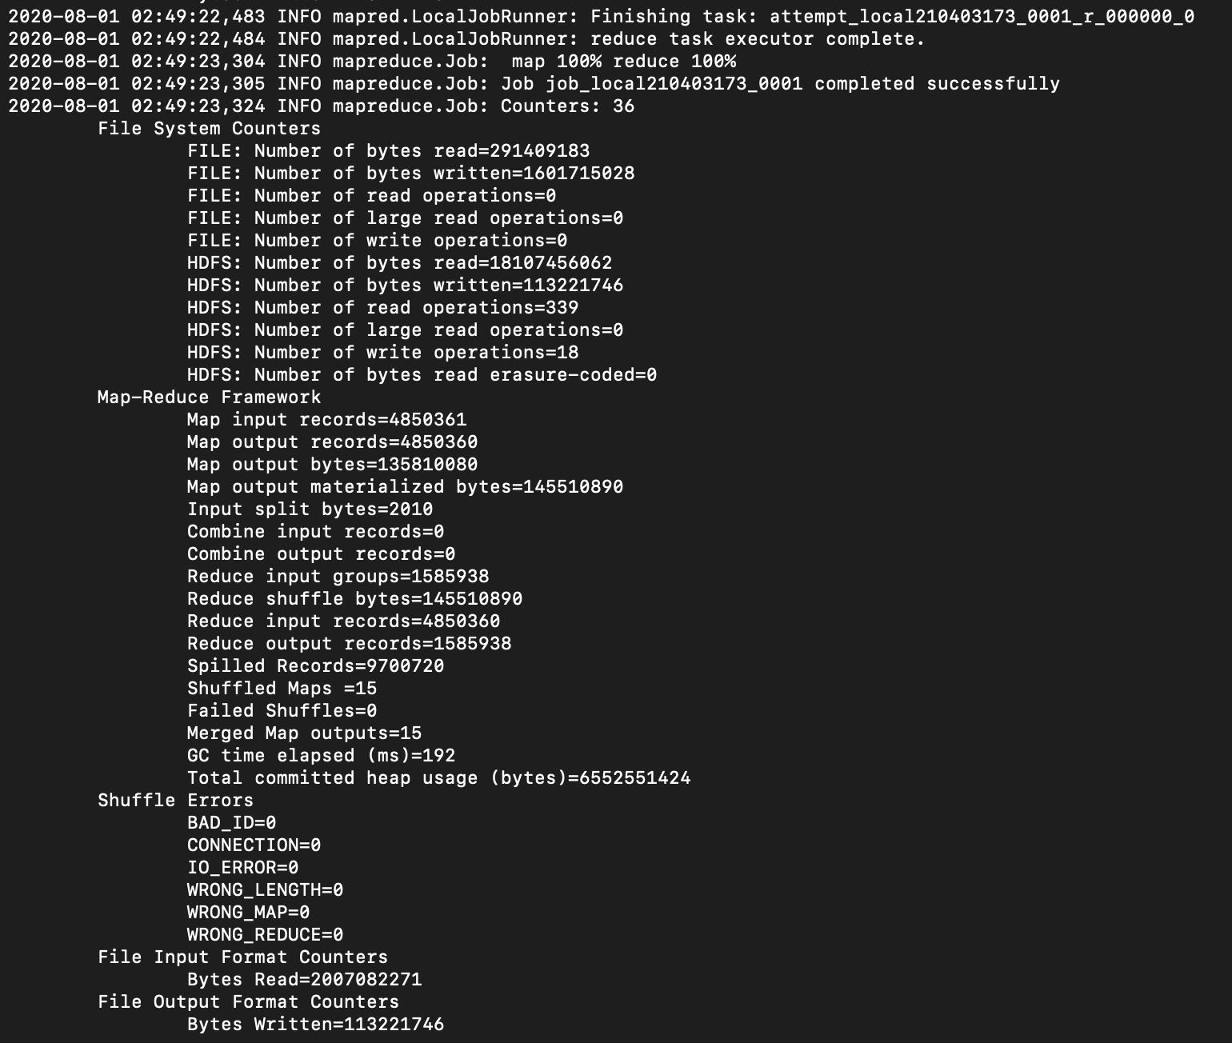

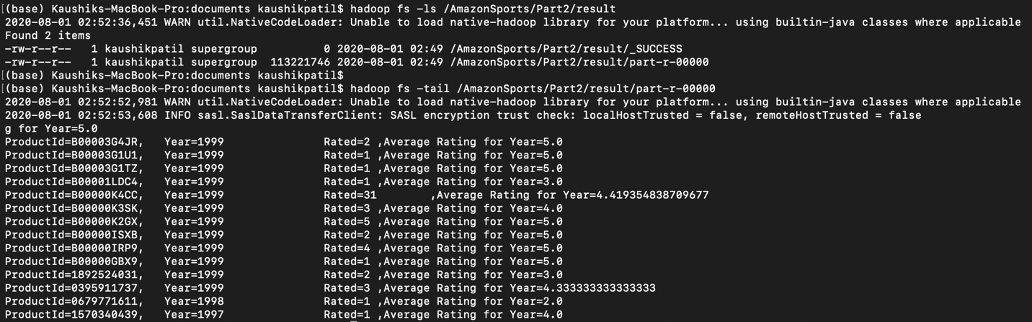

**Code**

**YearMapper**

package com.neu.edu.ratingperyear;

import java.io.IOException;

import java.text.SimpleDateFormat;

import java.util.Date;

import org.apache.hadoop.io.Text;

import org.apache.hadoop.mapreduce.Mapper;

/**

*

* @author kaushikpatil

*/

public class YearMapper extends Mapper <Object, Text, CompositeKeyWritable, AverageCountWritable>{

private AverageCountWritable averageCountRating = new AverageCountWritable();

@Override

public void map(Object key, Text value, Mapper<Object, Text, CompositeKeyWritable, AverageCountWritable>.Context context) throws IOException, InterruptedException {

String values[] = value.toString().split("\t");

String productId = null;

int year = 0;

double rating = 0.0D;

if(values[5] != null && values[7] != null && !values[0].equals("marketplace")) {

try {

productId = values[3];

SimpleDateFormat sdf = new SimpleDateFormat("yyyy-MM-dd");

Date reviewDate = sdf.parse(values[14]);

year = Integer.parseInt(reviewDate.toString().split(" ")[5]);

rating = Double.parseDouble(values[7]);

}catch(Exception e) {

e.printStackTrace();

}

if(year != 0 && productId != null) {

averageCountRating.setCount(1);

averageCountRating.setRatingAvg(rating);

CompositeKeyWritable ck = new CompositeKeyWritable(year, productId);

try {

context.write(ck, averageCountRating);

}catch (Exception e) {

e.printStackTrace();

}

}

}

}

}

**YearReducer**

package com.neu.edu.ratingperyear;

import java.io.IOException;

import org.apache.hadoop.io.NullWritable;

import org.apache.hadoop.mapreduce.Reducer;

/**

*

* @author kaushikpatil

*/

public class YearReducer extends Reducer <CompositeKeyWritable, AverageCountWritable, CompositeKeyWritable, AverageCountWritable> {

private AverageCountWritable res = new AverageCountWritable();

@Override

public void reduce(CompositeKeyWritable arg0, Iterable<AverageCountWritable> arg1, Reducer<CompositeKeyWritable,

AverageCountWritable, CompositeKeyWritable, AverageCountWritable>.Context arg2) throws IOException, InterruptedException {

double sum = 0;

int count = 0;

for(AverageCountWritable val: arg1) {

sum += val.getCount() * val.getRatingAvg();

count += val.getCount();

}

res.setCount(count);

res.setRatingAvg(sum/count);

arg2.write(arg0, res);

}

}

**Driver**

package com.neu.edu.ratingperyear;

import org.apache.hadoop.conf.Configuration;

import org.apache.hadoop.fs.FileSystem;

import org.apache.hadoop.fs.Path;

import org.apache.hadoop.mapreduce.Job;

import org.apache.hadoop.mapreduce.lib.input.FileInputFormat;

import org.apache.hadoop.mapreduce.lib.input.TextInputFormat;

import org.apache.hadoop.mapreduce.lib.output.FileOutputFormat;

/**

*

* @author kaushikpatil

*/

public class Driver {

public static void main(String[] args) throws Exception{

Path inputPath = new Path(args[0]);

Path outputDir = new Path(args[1]);

Configuration conf = new Configuration();

Job job = Job.getInstance(conf);

job.setJarByClass(YearMapper.class);

job.setPartitionerClass(YearPartitioner.class);

job.setGroupingComparatorClass(YearComparator.class);

job.setSortComparatorClass(SecSortingComparator.class);

job.setMapperClass(YearMapper.class);

job.setReducerClass(YearReducer.class);

job.setNumReduceTasks(1);

job.setMapOutputKeyClass(CompositeKeyWritable.class);

job.setMapOutputValueClass(AverageCountWritable.class);

job.setOutputKeyClass(CompositeKeyWritable.class);

job.setOutputValueClass(AverageCountWritable.class);

FileInputFormat.addInputPath(job, inputPath);

job.setInputFormatClass(TextInputFormat.class);

FileOutputFormat.setOutputPath(job, outputDir);

FileSystem hdfs = FileSystem.get(conf);

if (hdfs.exists(outputDir)){

hdfs.delete(outputDir, true);

}

int code = job.waitForCompletion(true) ? 0 : 1;

System.exit(code);

}

}

**CompositeKeyWritable**

package com.neu.edu.ratingperyear;

import java.io.DataInput;

import java.io.DataOutput;

import java.io.IOException;

import org.apache.hadoop.io.Writable;

import org.apache.hadoop.io.WritableComparable;

/**

*

* @author kaushikpatil

*/

public class CompositeKeyWritable implements Writable, WritableComparable<CompositeKeyWritable>{

private String productId;

private int year;

public CompositeKeyWritable() {

super();

}

public CompositeKeyWritable(int year, String productId) {

super();

this.year = year;

this.productId = productId;

}

public String getProductId() {

return productId;

}

public void setProductId(String productId) {

this.productId = productId;

}

public int getYear() {

return year;

}

public void setYear(int year) {

this.year = year;

}

public void readFields(DataInput in) throws IOException {

productId = in.readUTF();

year = in.readInt();

}

public void write(DataOutput out) throws IOException {

out.writeUTF(productId);

out.writeInt(year);

}

public int compareTo(CompositeKeyWritable o) {

int result = -1;

if(year > o.year) {

result = 1;

}

else if (year == o.year) {

result = 0;

}

else {

result = -1;

}

if(result == 0) {

result = productId.compareTo(o.productId);

}

return result;

}

@Override

public String toString() {

return "ProductId=" + productId + ",\t"+ "Year=" + year + "\t";

}

}

**AverageCountWritable**

package com.neu.edu.ratingperyear;

import java.io.DataInput;

import java.io.DataOutput;

import java.io.IOException;

import org.apache.hadoop.io.Writable;

/**

*

* @author kaushikpatil

*/

public class AverageCountWritable implements Writable{

public double RatingAvg;

public int count;

public AverageCountWritable(double RatingAvg, int count) {

super();

this.RatingAvg = RatingAvg;

this.count = count;

}

public AverageCountWritable() {

super();

}

public double getRatingAvg() {

return RatingAvg;

}

public void setRatingAvg(double RatingAvg) {

this.RatingAvg = RatingAvg;

}

public int getCount() {

return count;

}

public void setCount(int count) {

this.count = count;

}

public void readFields(DataInput in) throws IOException {

RatingAvg = in.readDouble();

count = in.readInt();

}

public void write(DataOutput out) throws IOException {

out.writeDouble(RatingAvg);

out.writeInt(count);

}

@Override

public String toString() {

return "Rated=" + count+ "\t"+",Average Rating for Year=" + RatingAvg;

}

}

**YearPartitioner**

package com.neu.edu.ratingperyear;

import org.apache.hadoop.io.NullWritable;

import org.apache.hadoop.mapreduce.Partitioner;

/**

*

* @author kaushikpatil

*/

public class YearPartitioner extends Partitioner <CompositeKeyWritable, NullWritable>{

@Override

public int getPartition(CompositeKeyWritable arg0, NullWritable arg1, int numOfReducerTasks) {

int hash = arg0.getProductId().hashCode();

int partition = hash % numOfReducerTasks;

return partition;

}

}

**YearComparator**

package com.neu.edu.ratingperyear;

import org.apache.hadoop.io.WritableComparable;

import org.apache.hadoop.io.WritableComparator;

/**

*

* @author kaushikpatil

*/

public class YearComparator extends WritableComparator{

protected YearComparator() {

super(CompositeKeyWritable.class, true);

}

@Override

public int compare(WritableComparable a, WritableComparable b) {

CompositeKeyWritable ck1 = (CompositeKeyWritable) a;

CompositeKeyWritable ck2 = (CompositeKeyWritable) b;

return ck1.getProductId().compareTo(ck2.getProductId());

}

}

**SecSortingComparator**

package com.neu.edu.ratingperyear;

import org.apache.hadoop.io.WritableComparable;

import org.apache.hadoop.io.WritableComparator;

/**

*

* @author kaushikpatil

*/

public class SecSortingComparator extends WritableComparator{

protected SecSortingComparator() {

super(CompositeKeyWritable.class, true);

}

@Override

public int compare(WritableComparable a, WritableComparable b) {

CompositeKeyWritable ck1 = (CompositeKeyWritable) a;

CompositeKeyWritable ck2 = (CompositeKeyWritable) b;

int result = 0;

if(ck1.getYear() > ck2.getYear()) {

result = 1;

}

else if (ck1.getYear() == ck2.getYear()) {

result = 0;

}

else {

result = -1;

}

if(result == 0) {

result = ck1.getProductId().compareTo(ck2.getProductId());

}

return result*(-1);

}

}

**Number of Products per Rating (Counter using Numerical Summarization Pattern)**

How can we know which products are good or bad? Which products are liked by customers?

So, we can determine this by knowing the ratings of the products and then dividing them on a scale of 5.

I have used counter for the ratings to count the number of products per rating using Numerical Summarization Pattern. We have a class called Rating and a Mapper.

**Outputs**

hadoop jar 3.ProdPerRating-1.0-SNAPSHOT.jar com.neu.edu.prodperrating.Rating /AmazonSports/amazon_reviews_us_Sports_v1_00.tsv /AmazonSports/Part3/result3

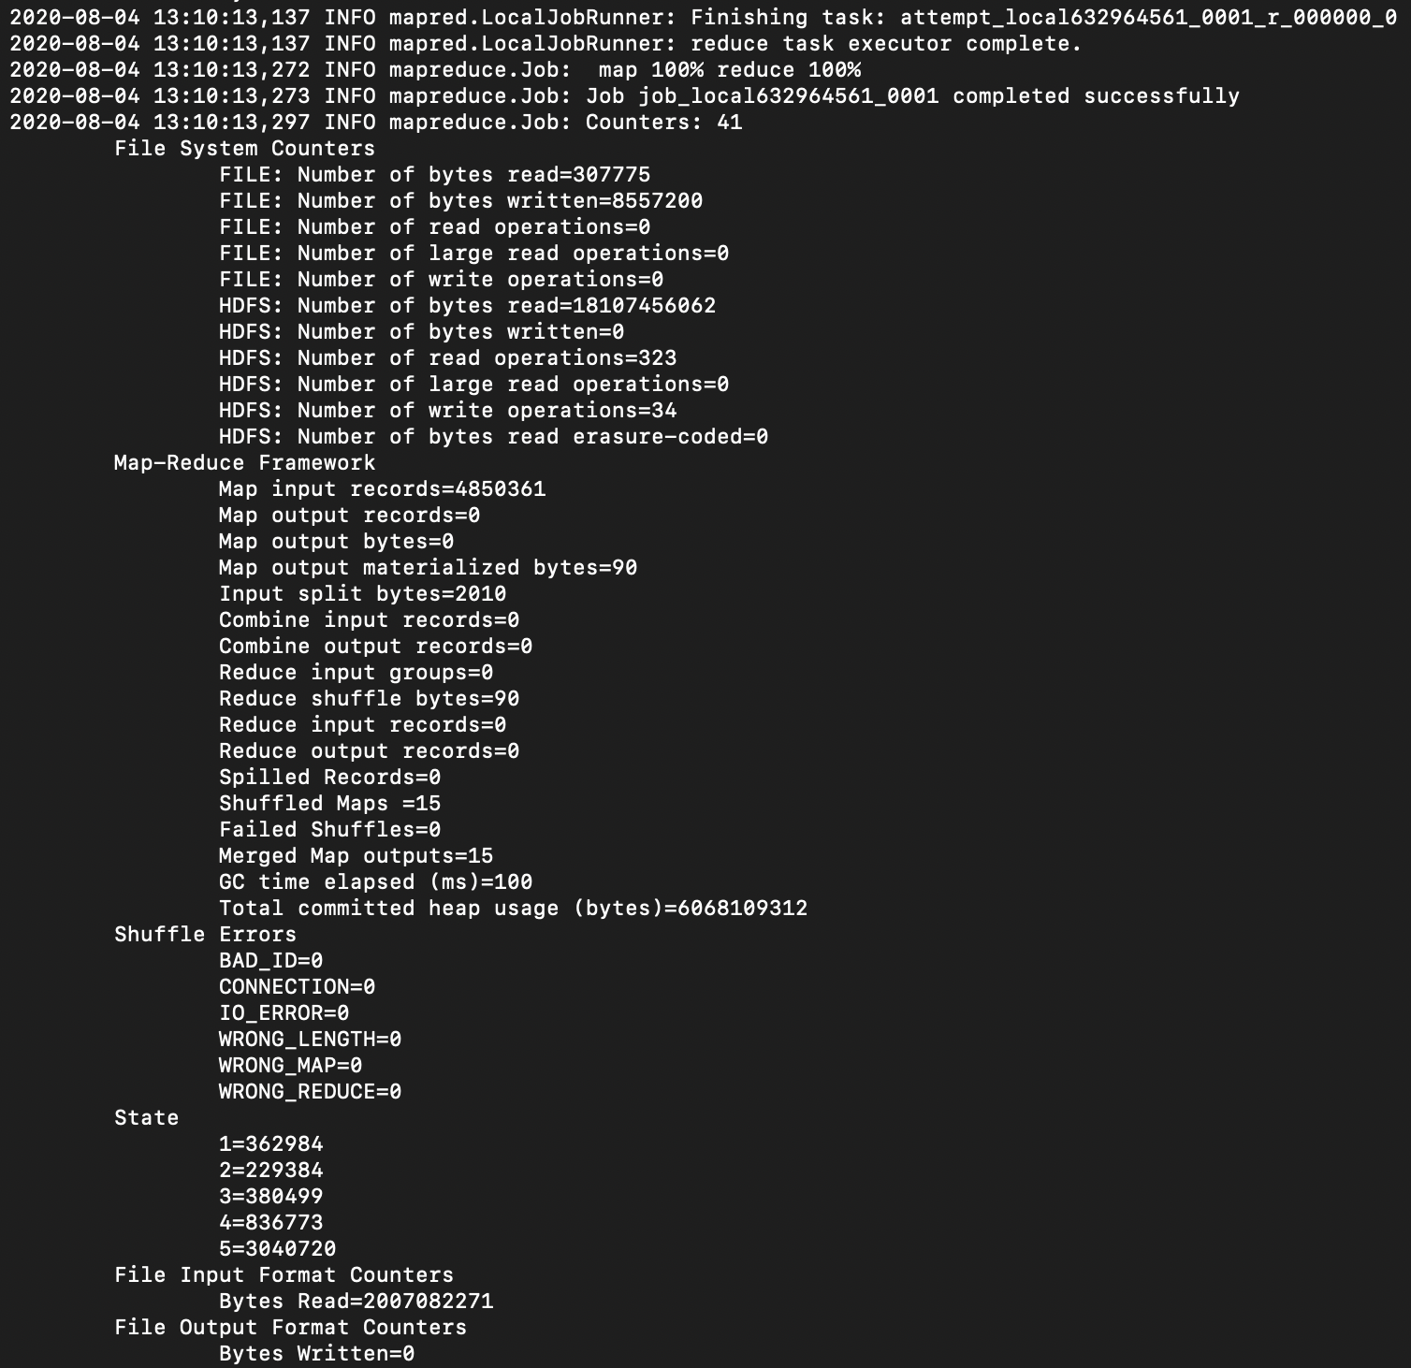

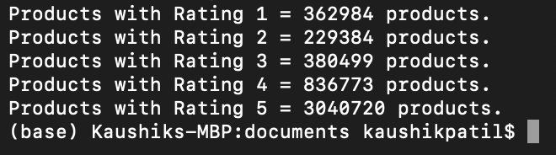

**Code**

**Rating**

package com.neu.edu.prodperrating;

import java.io.IOException;

import java.util.Arrays;

import java.util.HashSet;

import org.apache.hadoop.conf.Configuration;

import org.apache.hadoop.fs.FileSystem;

import org.apache.hadoop.fs.Path;

import org.apache.hadoop.io.LongWritable;

import org.apache.hadoop.io.Text;

import org.apache.hadoop.mapreduce.Counter;

import org.apache.hadoop.mapreduce.Job;

import org.apache.hadoop.mapreduce.Mapper;

import org.apache.hadoop.mapreduce.lib.input.FileInputFormat;

import org.apache.hadoop.mapreduce.lib.output.FileOutputFormat;

/**

*

* @author kaushikpatil

*/

public class Rating {

public static void main(String[] args) throws IOException, InterruptedException, ClassNotFoundException {

Configuration conf = new Configuration();

Job job = Job.getInstance(conf, "Products per Rating");

job.setJarByClass(Rating.class);

job.setMapperClass(ProdMapper.class);

job.setMapOutputKeyClass(Text.class);

job.setMapOutputValueClass(Text.class);

FileInputFormat.addInputPath(job, new Path(args[0]));

FileOutputFormat.setOutputPath(job, new Path(args[1]));

Path out = new Path(args[1]);

FileSystem.get(conf).delete(out, true);

int code = job.waitForCompletion(true) ? 0 : 1;

if(code==0){

for(Counter counter : job.getCounters().getGroup(ProdMapper.STATE_COUNTER_GROUP)){

{

System.out.println("Products with Rating "+counter.getDisplayName()+" = "+counter.getValue()+" products.");

}

}

}

System.exit(code);

}

public static class ProdMapper extends Mapper<LongWritable, Text, Text, Text>{

public static final String STATE_COUNTER_GROUP = "State";

public static final String UNKNOWN_COUNTER = "Unknown";

public static final String NULL_OR_EMPTY_COUNTER = "Null or empty";

private String[] statesArray = new String[] {"1", "2", "3", "4", "5"};

private HashSet<String> states = new HashSet<String>(Arrays.asList(statesArray));

public void map (LongWritable key, Text value, Context context) throws IOException, InterruptedException{

if(key.get()==0){

return;

}

String[] token = value.toString().split("\t");

String stateName = token[7].trim();

if(stateName != null && !stateName.isEmpty()){

String[] stateTokens = stateName.toUpperCase().split("\\s");

boolean unknown = true;

for(String state: stateTokens){

if(state.contains(state)){

context.getCounter(STATE_COUNTER_GROUP, state).increment(1);

unknown = false;

break;

}

}

if(unknown){

context.getCounter(STATE_COUNTER_GROUP, UNKNOWN_COUNTER).increment(1);

}

} else{

context.getCounter(STATE_COUNTER_GROUP, NULL_OR_EMPTY_COUNTER).increment(1);

}

}

}

}

**Data Visualization**

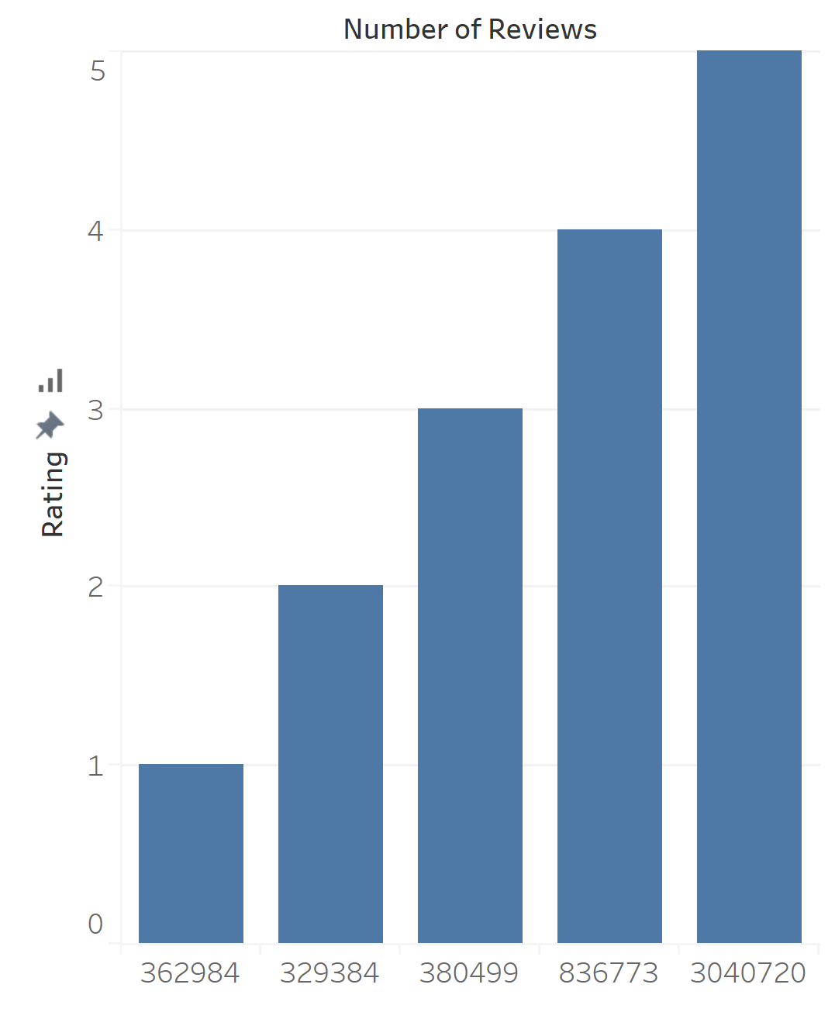

**Segregation of all Products based on their rating (Binning Organization Pattern)**

We have segregated all the products and their details based on the rating into small bins which consists of products of that specific reviews and ratings only

This is achieved by Binning Organization Pattern. We have used Driver and Mapper as this method doesn’t require any reducer, partitioner etc.

**Outputs**

hadoop jar 4.RatingBinning-1.0-SNAPSHOT.jar com.neu.edu.ratingbinning.RatingBinning /AmazonSports/amazon_reviews_us_Sports_v1_00.tsv /AmazonSports/Part4/result4

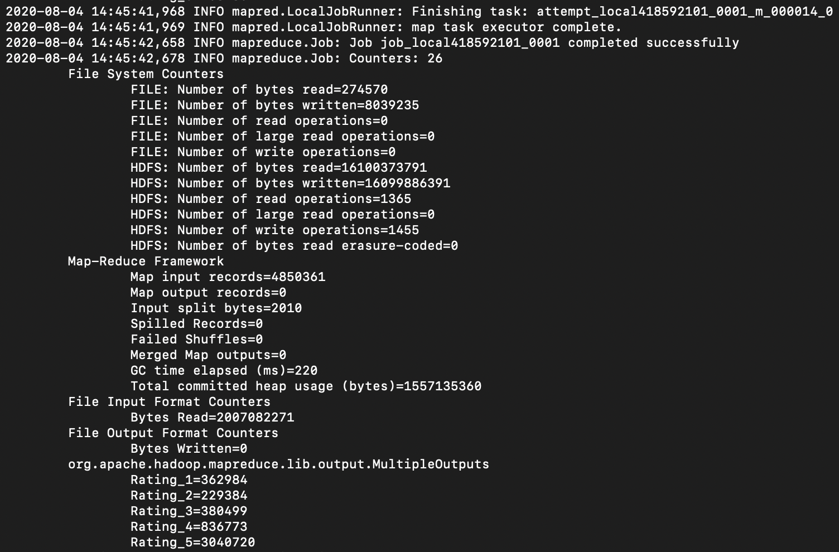

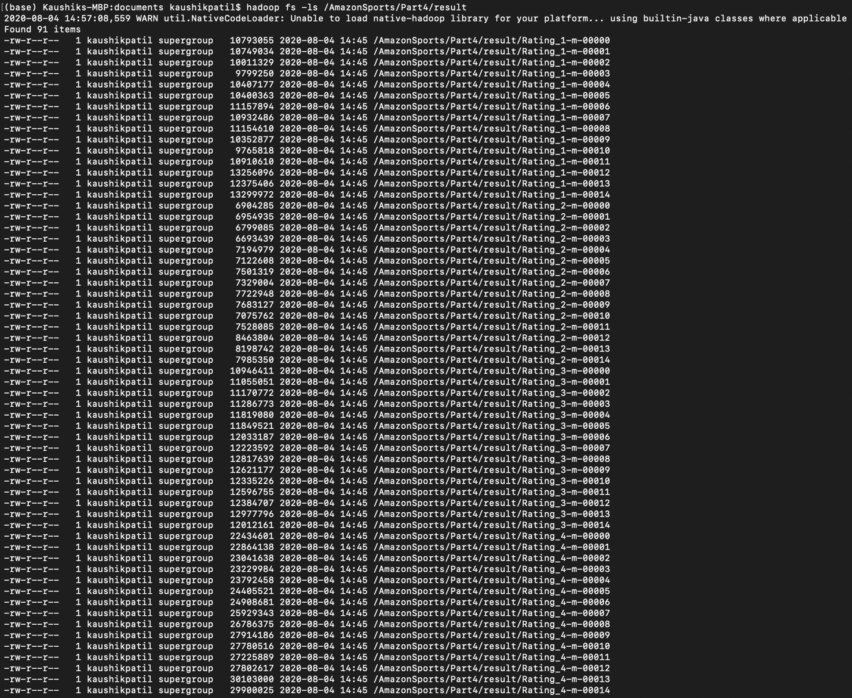

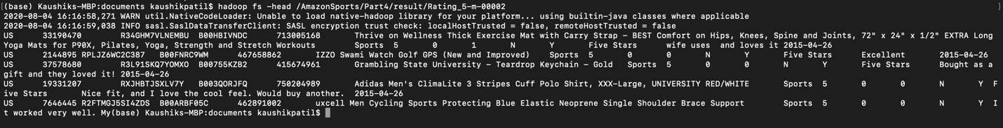

**Code**

**RatingBinner**

package com.neu.edu.ratingbinning;

import java.io.IOException;

import org.apache.hadoop.conf.Configuration;

import org.apache.hadoop.fs.Path;

import org.apache.hadoop.io.LongWritable;

import org.apache.hadoop.io.NullWritable;

import org.apache.hadoop.io.Text;

import org.apache.hadoop.mapreduce.Job;

import org.apache.hadoop.mapreduce.Mapper;

import org.apache.hadoop.mapreduce.lib.input.TextInputFormat;

import org.apache.hadoop.mapreduce.lib.output.FileOutputFormat;

import org.apache.hadoop.mapreduce.lib.output.MultipleOutputs;

import org.apache.hadoop.mapreduce.lib.output.TextOutputFormat;

/**

*

* @author kaushikpatil

*/

public class RatingBinning {

public static void main(String[] args)throws IOException, InterruptedException, ClassNotFoundException {

Configuration conf = new Configuration();

Job job = Job.getInstance(conf, "Rating Binning");

job.setJarByClass(RatingBinning.class);

job.setMapperClass(RatingBinningMapper.class);

job.setMapOutputKeyClass(Text.class);

job.setMapOutputValueClass(NullWritable.class);

job.setNumReduceTasks(0);

TextInputFormat.addInputPath(job, new Path(args[0]));

FileOutputFormat.setOutputPath(job, new Path(args[1]));

MultipleOutputs.addNamedOutput(job, "bins", TextOutputFormat.class, Text.class, NullWritable.class);

MultipleOutputs.setCountersEnabled(job, true);

System.exit(job.waitForCompletion(true) ? 0 : 1);

}

public static class RatingBinningMapper extends Mapper<LongWritable, Text, Text, NullWritable> {

private MultipleOutputs<Text, NullWritable> mos = null;

protected void setup(Context context) {

mos = new MultipleOutputs(context);

}

protected void map(LongWritable key, Text value, Context context) throws IOException, InterruptedException {

if (key.get() == 0) {

return;

}

String[] token = value.toString().split("\\t");

{

String rating = token[7].trim();

if (rating.equals("1")) {

mos.write("bins", value, NullWritable.get(), "Rating_1");

}

if (rating.equals("2")) {

mos.write("bins", value, NullWritable.get(), "Rating_2");

}

if (rating.equals("3")) {

mos.write("bins", value, NullWritable.get(), "Rating_3");

}

if (rating.equals("4")) {

mos.write("bins", value, NullWritable.get(), "Rating_4");

}

if (rating.equals("5")) {

mos.write("bins", value, NullWritable.get(), "Rating_5");

}

}

}

protected void cleanup(Context context) throws IOException, InterruptedException {

mos.close();

}

}

}

**Top 25 Best Products based on average ratings (Filtering Pattern)**

We should know the products which are doing well for customer satisfaction for keeping the track of demand and supply.

We can use filtering pattern for getting the top 25 Best products based on their average ratings from the dataset.

Here we will use two mappers, two reducers, comparator and driver. The first map reduce will get the average of all reviews for all products. The second map reduce will get only the top 25 best products using the counter.

**Outputs**

hadoop jar 5.Top25Products-1.0-SNAPSHOT.jar com.neu.edu.topproducts.Driver /AmazonSports/amazon_reviews_us_Sports_v1_00.tsv /AmazonSports/Part5/result1 /AmazonSports/Part5/result2

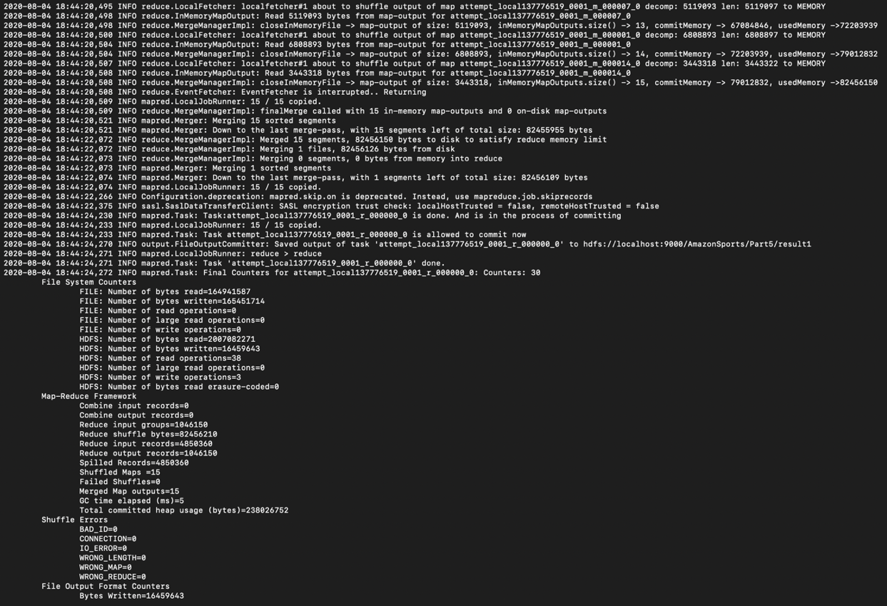

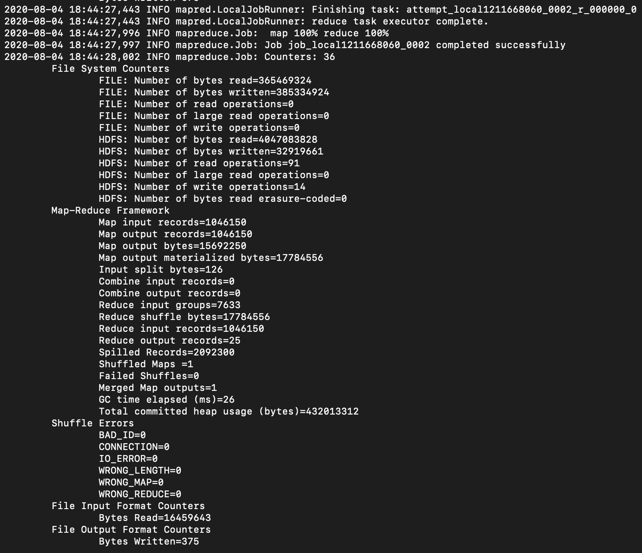

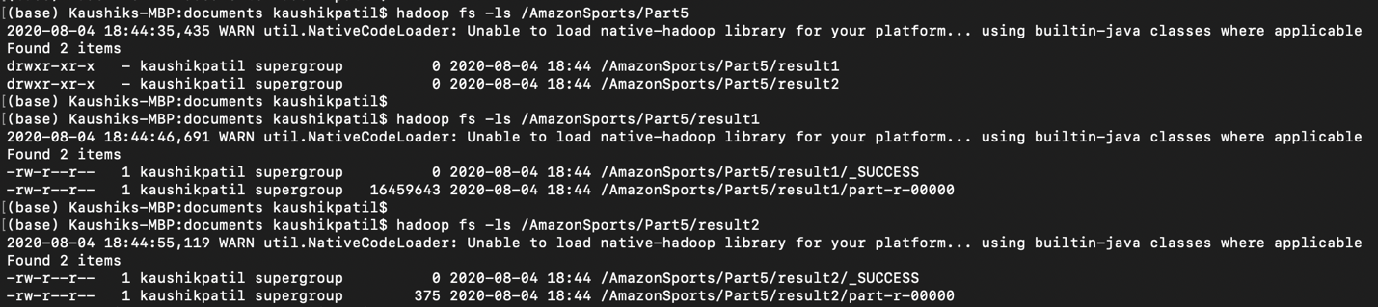

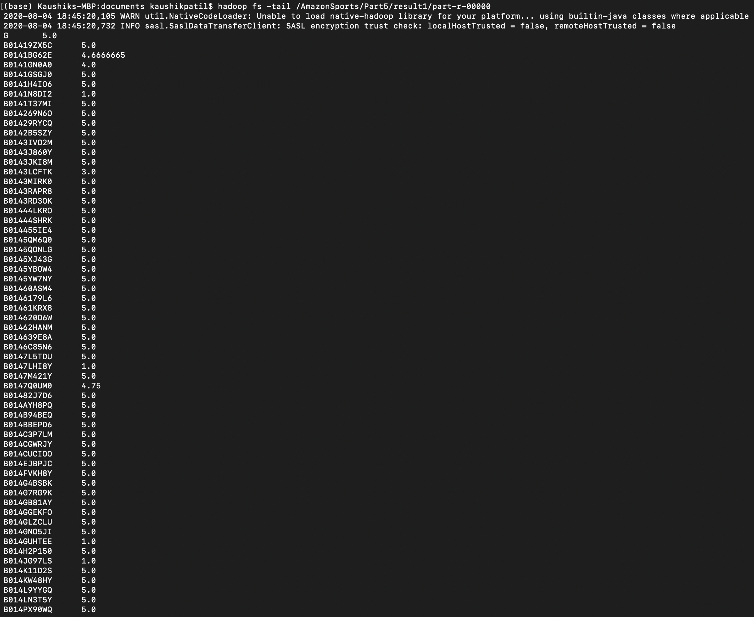

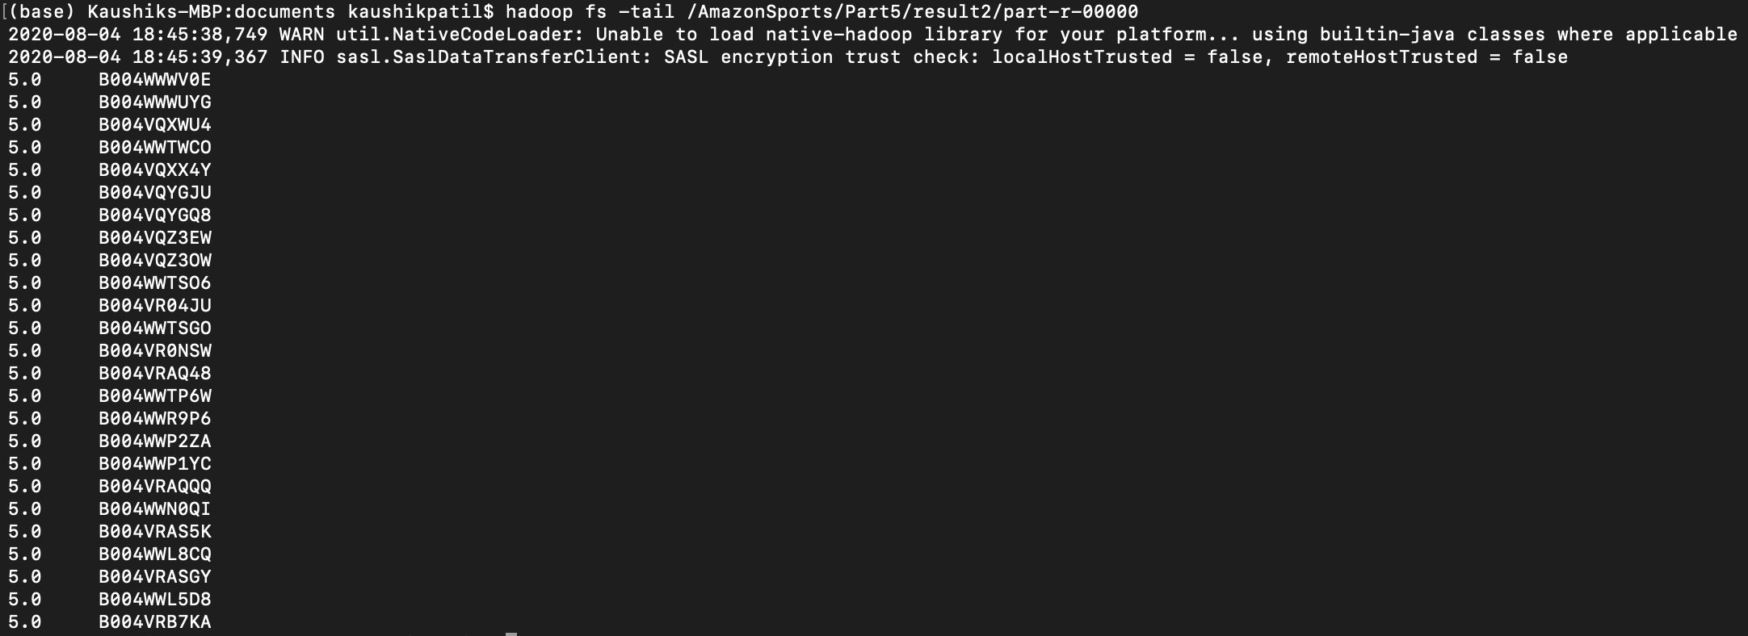

**Code**

**TopMapper1**

package com.neu.edu.topproducts;

import java.io.IOException;

import org.apache.hadoop.io.FloatWritable;

import org.apache.hadoop.io.LongWritable;

import org.apache.hadoop.io.Text;

import org.apache.hadoop.mapreduce.Mapper;

/**

*

* @author kaushikpatil

*/

public class TopMapper1 extends Mapper<LongWritable, Text, Text, FloatWritable> {

private Text text = new Text();

private FloatWritable score = new FloatWritable();

protected void map(LongWritable key, Text value, Context context) throws IOException, InterruptedException {

if(key.get()==0){

return;

}

else{

String[] line = value.toString().split("\\t");

String productid = line[3].trim();

float rating = Float.valueOf(line[7].trim());

text.set(productid);

score.set(rating);

context.write(text,score);

}

}

}

**TopMapper2**

package com.neu.edu.topproducts;

import org.apache.hadoop.io.FloatWritable;

import org.apache.hadoop.io.LongWritable;

import org.apache.hadoop.io.Text;

import org.apache.hadoop.mapreduce.Mapper;

/**

*

* @author kaushikpatil

*/

public class TopMapper2 extends Mapper<LongWritable, Text, FloatWritable, Text> {

public void map(LongWritable key, Text value, Context context) {

String[] row = value.toString().split("\\t");

String productid = row[0].trim();

float prodrating = Float.parseFloat(row[1].trim());

try {

Text id = new Text(productid);

FloatWritable prod = new FloatWritable(prodrating);

context.write(prod, id); }

catch (Exception e) {

}

}

}

**TopReducer1**

package com.neu.edu.topproducts;

import java.io.IOException;

import org.apache.hadoop.io.FloatWritable;

import org.apache.hadoop.io.Text;

import org.apache.hadoop.mapreduce.Reducer;

/**

*

* @author kaushikpatil

*/

public class TopReducer1 extends Reducer<Text, FloatWritable, Text, FloatWritable>{

private FloatWritable result = new FloatWritable();

@Override

protected void reduce(Text key, Iterable<FloatWritable> values, Context context) throws IOException, InterruptedException{

float sum = 0;

int count = 0;

for(FloatWritable val:values){

sum+=val.get();

count = count+1;

}

float average = sum/count;

result.set(average);

context.write(key,result);

}

}

**TopReducer2**

package com.neu.edu.topproducts;

import java.io.IOException;

import org.apache.hadoop.io.FloatWritable;

import org.apache.hadoop.io.Text;

import org.apache.hadoop.mapreduce.Reducer;

/**

*

* @author kaushikpatil

*/

public class TopReducer2 extends Reducer<FloatWritable, Text, FloatWritable, Text> {

int count = 0;

public void reduce(FloatWritable key, Iterable<Text> value, Context context) throws IOException, InterruptedException {

for (Text val : value) {

if (count < 25) {

context.write(key, val);

}

count++;

}

}

}

**TopComparator**

package com.neu.edu.topproducts;

import org.apache.hadoop.io.FloatWritable;

import org.apache.hadoop.io.WritableComparable;

import org.apache.hadoop.io.WritableComparator;

/**

*

* @author kaushikpatil

*/

public class TopComparator extends WritableComparator {

protected TopComparator() {

super(FloatWritable.class, true);

}

public int compare(WritableComparable f1, WritableComparable f2) {

FloatWritable fw1 = (FloatWritable) f1;

FloatWritable fw2 = (FloatWritable) f2;

int result = fw1.get() < fw2.get() ? 1 : fw1.get() == fw2.get() ? 0 : -1;

return result;

}

}

**Driver**

package com.neu.edu.topproducts;

import java.io.IOException;

import org.apache.hadoop.conf.Configuration;

import org.apache.hadoop.fs.Path;

import org.apache.hadoop.io.FloatWritable;

import org.apache.hadoop.io.Text;

import org.apache.hadoop.mapreduce.Job;

import org.apache.hadoop.mapreduce.lib.input.FileInputFormat;

import org.apache.hadoop.mapreduce.lib.output.FileOutputFormat;

/**

*

* @author kaushikpatil

*/

public class Driver {

public static void main(String[] args) throws IOException, InterruptedException, ClassNotFoundException {

Configuration conf1 = new Configuration();

Job job1 = Job.getInstance(conf1, "Best 25 Products");

job1.setJarByClass(Driver.class);

job1.setMapperClass(TopMapper1.class);

job1.setMapOutputKeyClass(Text.class);

job1.setMapOutputValueClass(FloatWritable.class);

job1.setReducerClass(TopReducer1.class);

job1.setOutputKeyClass(Text.class);

job1.setOutputValueClass(FloatWritable.class);

FileInputFormat.addInputPath(job1, new Path(args[0]));

FileOutputFormat.setOutputPath(job1, new Path(args[1]));

boolean complete = job1.waitForCompletion(true);

Configuration conf2 = new Configuration();

if (complete) {

Job job2 = Job.getInstance(conf2, "Best 25 Products");

job2.setJarByClass(Driver.class);

job2.setMapperClass(TopMapper2.class);

job2.setMapOutputKeyClass(FloatWritable.class);

job2.setMapOutputValueClass(Text.class);

job2.setSortComparatorClass(TopComparator.class);

job2.setReducerClass(TopReducer2.class);

job2.setOutputKeyClass(FloatWritable.class);

job2.setOutputValueClass(Text.class);

FileInputFormat.addInputPath(job2, new Path(args[1]));

FileOutputFormat.setOutputPath(job2, new Path(args[2]));

System.exit(job2.waitForCompletion(true) ? 0 : 1);

}

}

}

**Data Visualization**

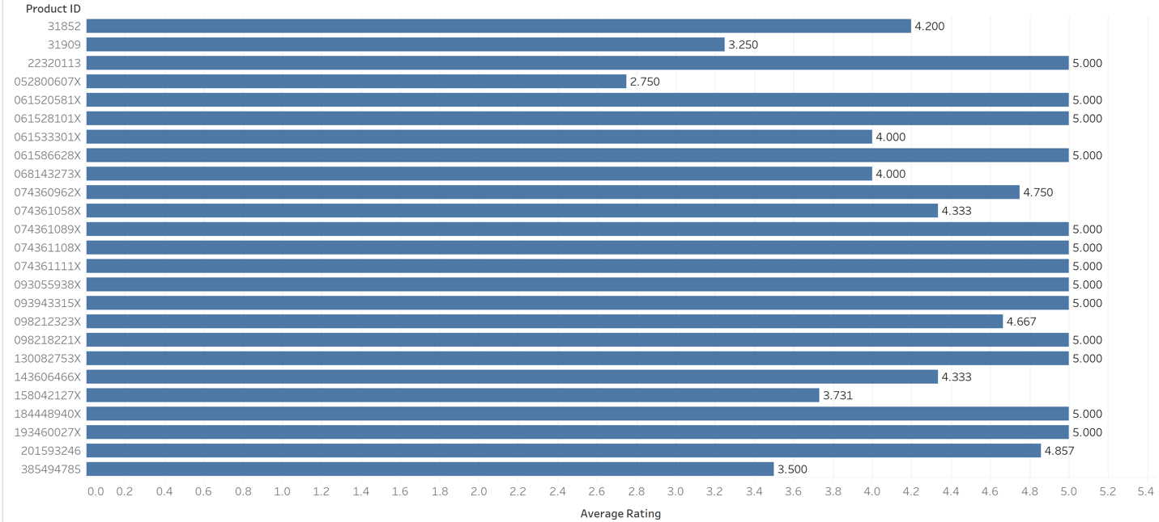

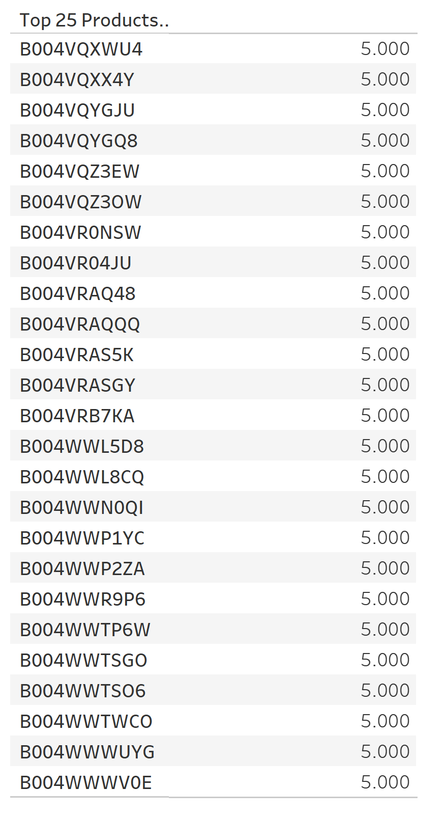

**List of customers for each product who have given review (Distinct or Inverted Index Pattern)**

We should know which customer has given reviews to which products so that we can keep track of the customers who value the products often.

This can be done by Distinct or Inverted Index Pattern MapReduce Algorithm.

**Outputs**

hadoop jar 6.DistinctCustomerReviews-1.0-SNAPSHOT.jar com.neu.edu.distinctcustomerreviews.Driver /AmazonSports/amazon_reviews_us_Sports_v1_00.tsv /AmazonSports/Part6/result6

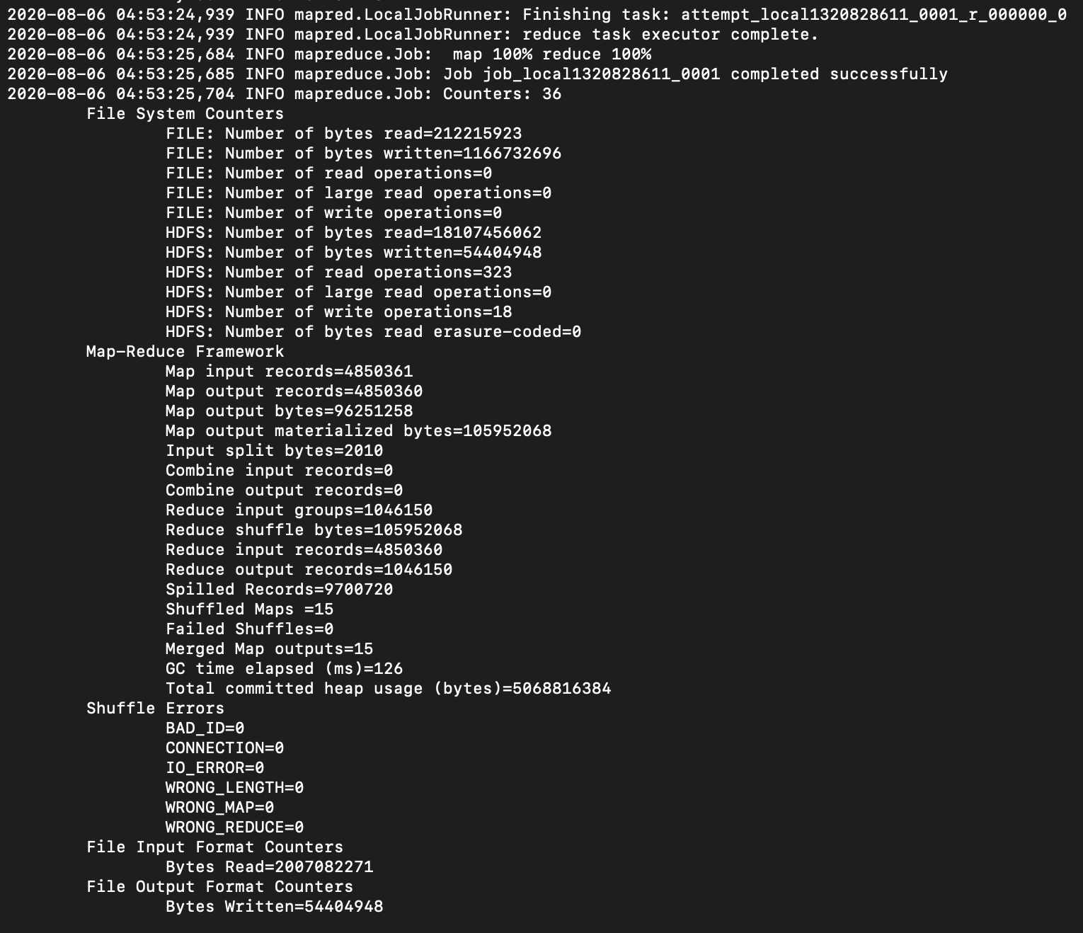



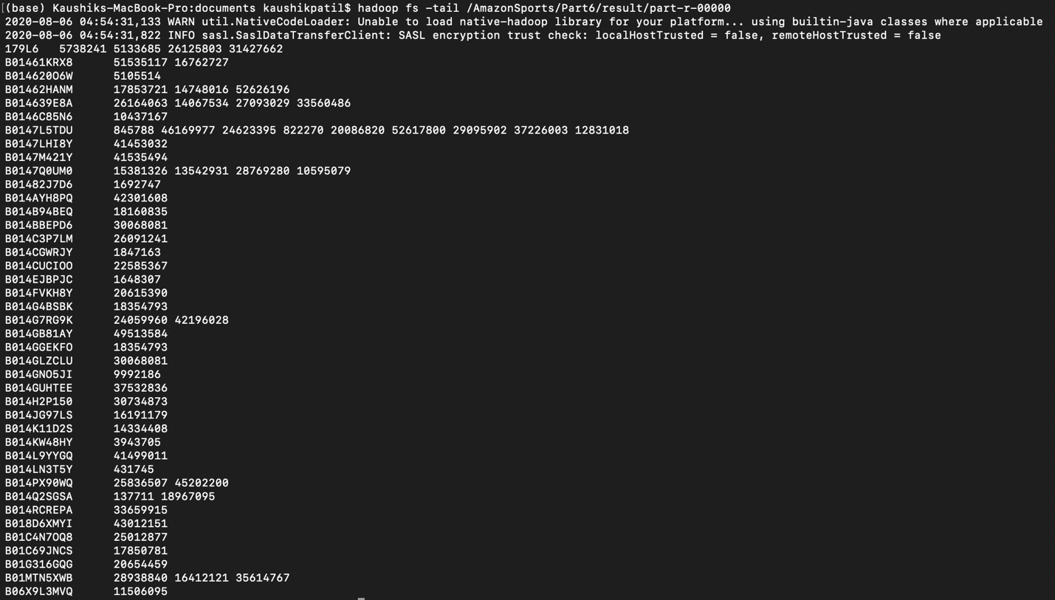

**Code**

**CustomerMapper**

package com.neu.edu.distinctcustomerreviews;

import java.io.IOException;

import org.apache.hadoop.io.LongWritable;

import org.apache.hadoop.io.Text;

import org.apache.hadoop.mapreduce.Mapper;

/**

*

* @author kaushikpatil

*/

public class CustomerMapper extends Mapper<LongWritable, Text, Text, Text> {

private Text product = new Text();

private Text customerid = new Text();

public void map(LongWritable key, Text values, Context context) throws IOException {

if (key.get() == 0) {

return;

}

String[] tokens = values.toString().split("\\t");

customerid.set(tokens[1]);

product.set(tokens[3]);

try {

context.write(product, customerid);

}

catch (InterruptedException e) {

e.printStackTrace();

}

}

}

**CustomerReducer**

package com.neu.edu.distinctcustomerreviews;

import java.io.IOException;

import org.apache.hadoop.io.Text;

import org.apache.hadoop.mapreduce.Reducer;

/**

*

* @author kaushikpatil

*/

public class CustomerReducer extends Reducer<Text, Text, Text, Text> {

private Text result = new Text();

@Override

public void reduce(Text key, Iterable<Text> values, Context context) throws IOException, InterruptedException {

StringBuilder sb = new StringBuilder();

boolean first = true;

for (Text id : values) {

if (first) {

first = false;

} else { sb.append(" ");

}

sb.append(id.toString());

} result.set(sb.toString());

context.write(key, result);

}

}

**Driver**

package com.neu.edu.distinctcustomerreviews;

import java.io.IOException;

import org.apache.hadoop.conf.Configuration;

import org.apache.hadoop.fs.Path;

import org.apache.hadoop.io.Text;

import org.apache.hadoop.mapreduce.Job;

import org.apache.hadoop.mapreduce.lib.input.FileInputFormat;

import org.apache.hadoop.mapreduce.lib.output.FileOutputFormat;

/**

*

* @author kaushikpatil

*/

public class Driver {

public static void main(String[] args)throws IOException, InterruptedException, ClassNotFoundException {

Configuration conf = new Configuration();

Job job = Job.getInstance(conf,"Customer Details");

job.setJarByClass(Driver.class);

job.setMapperClass(CustomerMapper.class);

job.setReducerClass(CustomerReducer.class);

job.setMapOutputKeyClass(Text.class);

job.setMapOutputValueClass(Text.class);

job.setOutputKeyClass(Text.class);

job.setOutputValueClass(Text.class);

FileInputFormat.addInputPath(job, new Path(args[0]));

FileOutputFormat.setOutputPath(job, new Path(args[1]));

System.exit(job.waitForCompletion(true) ? 0 : 1);

}

}

**Legit Customer Review Analysis (Numerical Summarization Pattern)**

Customer Product Helpful Ratio can be calculated by taking two columns – helpful_votes and total_votes in the dataset.

This is to be calculated to get the percentage of actual legit and helpful customer reviews which will be useful in customer product analysis.

**Outputs**

hadoop jar 7.LegitCustomerAnalysis-1.0-SNAPSHOT.jar com.neu.edu.legitcustomeranalysis.Driver /AmazonSports/amazon_reviews_us_Sports_v1_00.tsv /AmazonSports/Part7/result7

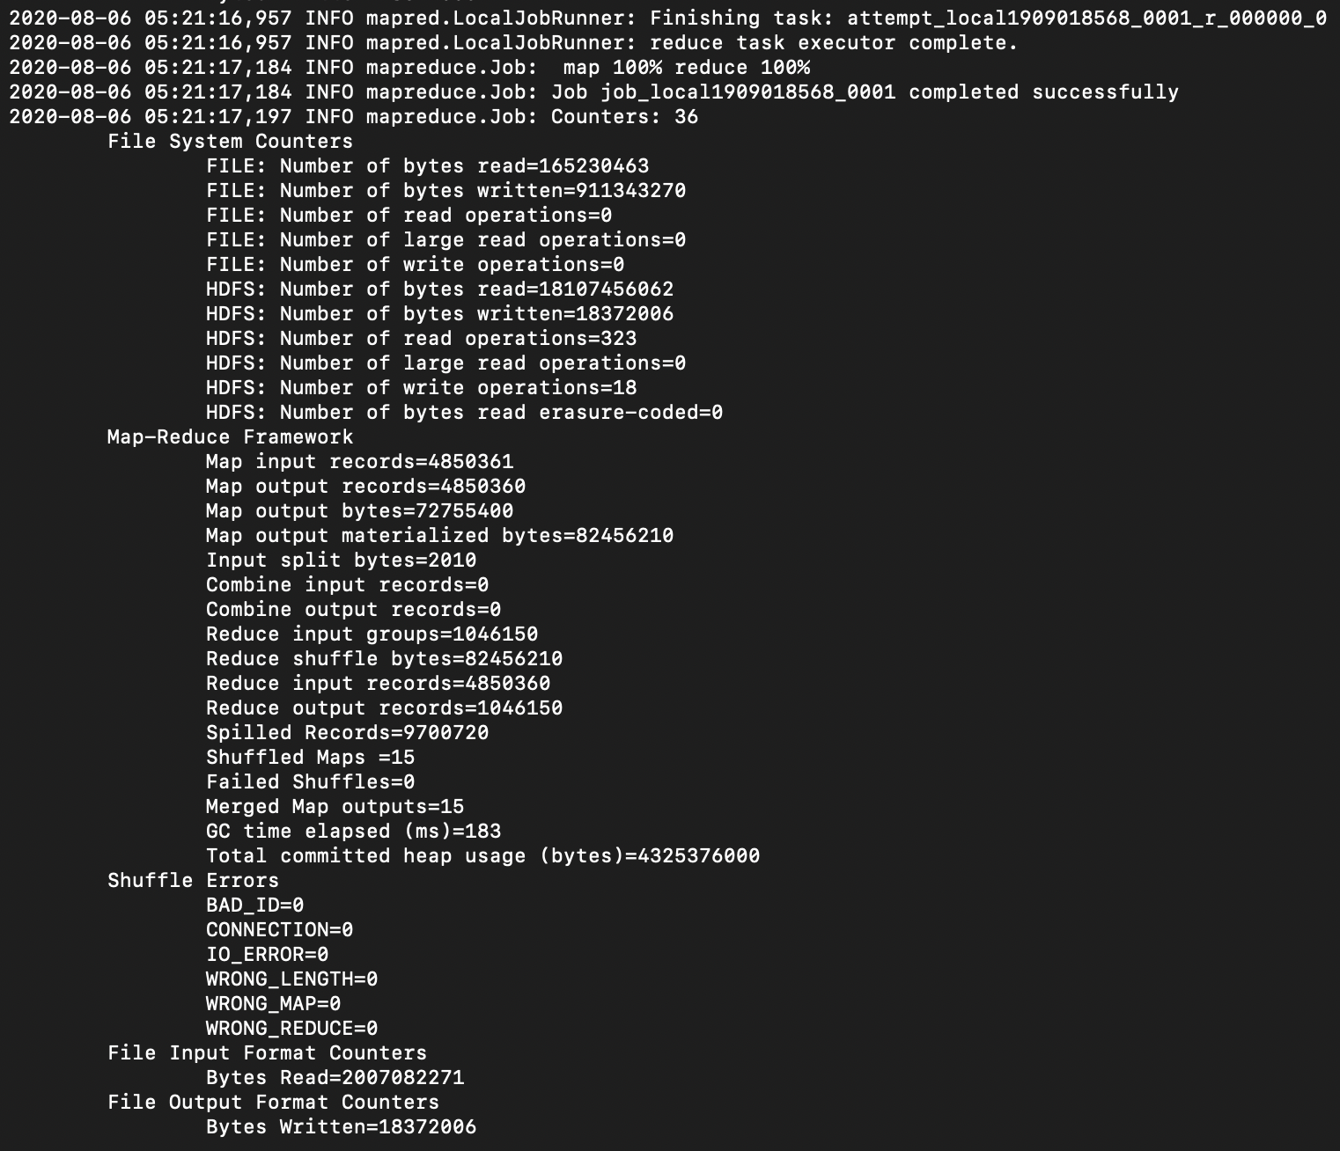



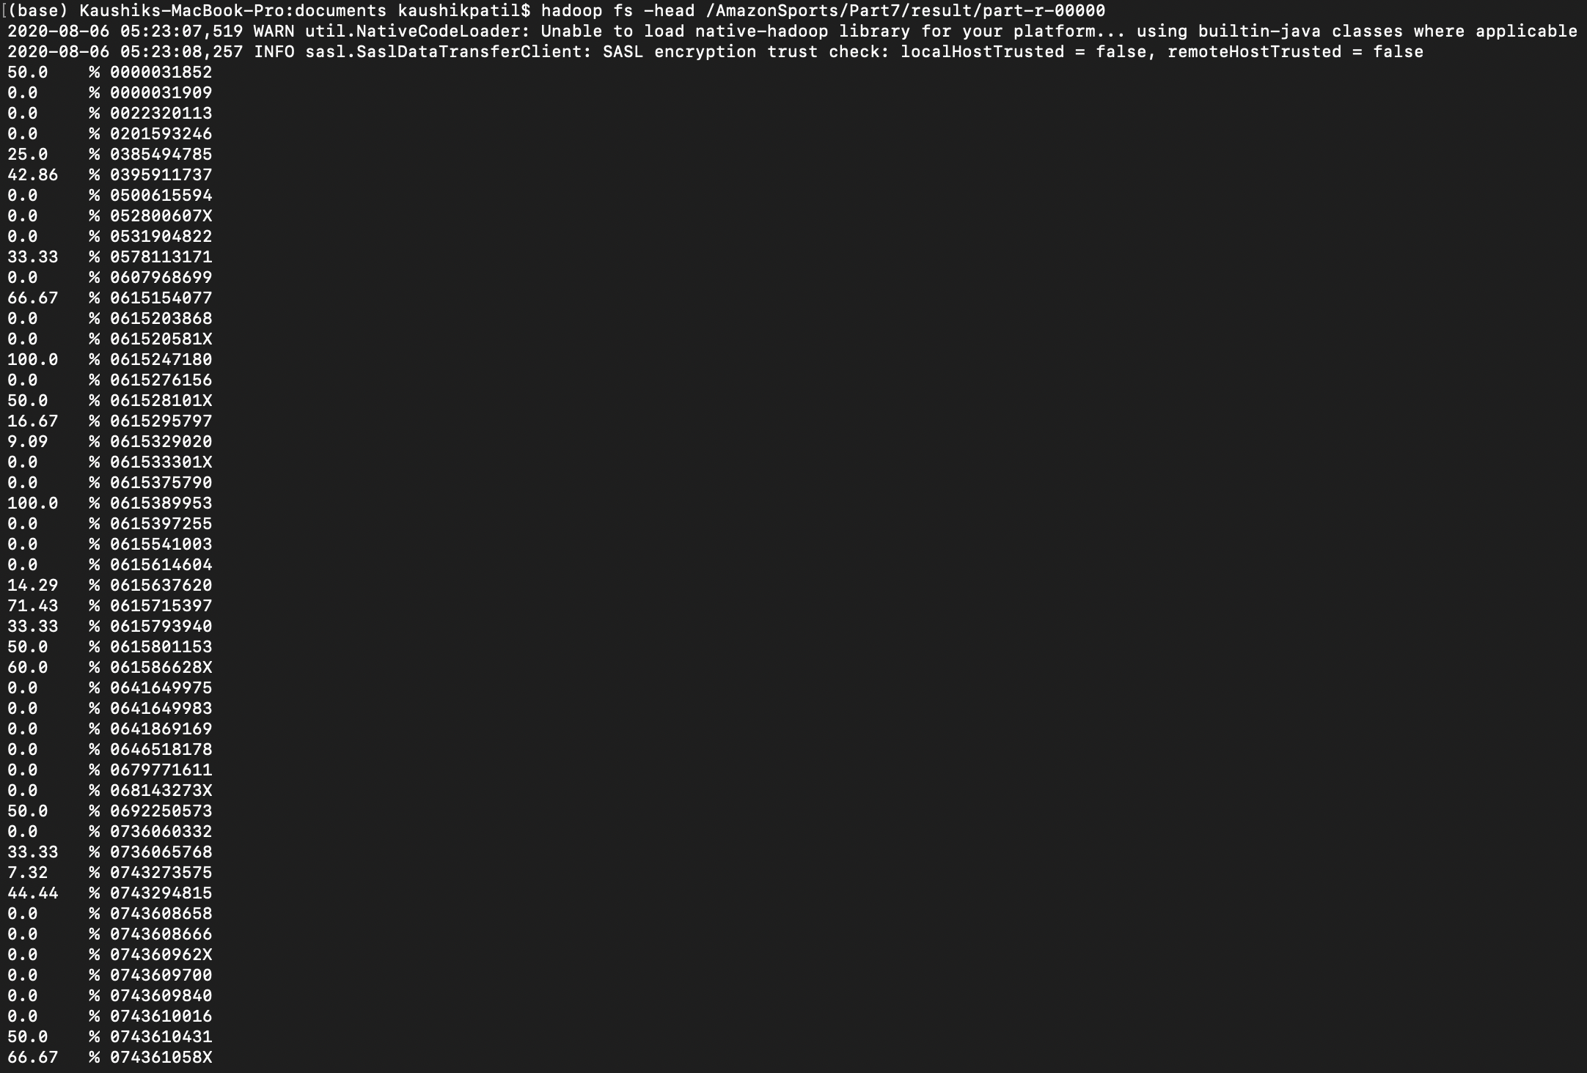

**Code**

**HelpfulMapper**

package com.neu.edu.legitcustomeranalysis;

import java.io.IOException;

import org.apache.hadoop.io.FloatWritable;

import org.apache.hadoop.io.LongWritable;

import org.apache.hadoop.io.Text;

import org.apache.hadoop.mapreduce.Mapper;

/**

*

* @author kaushikpatil

*/

public class HelpfulMapper extends Mapper<LongWritable, Text, Text, FloatWritable> {

private Text text = new Text();

private FloatWritable score = new FloatWritable();

@Override

protected void map(LongWritable key, Text value, Context context) throws IOException, InterruptedException {

if (key.get() == 0) {

return;

} else {

String[] line = value.toString().split("\\t");

String productid = line[3].trim();

int num = Integer.parseInt(line[8].trim());

int deno = Integer.parseInt(line[9].trim());

float rat;

if (deno != 0) {

rat = num / deno;

} else {

rat = (float) 0.0;

}

text.set(productid);

score.set(rat);

context.write(text, score);

}

}

}

**HelpfulReducer**

package com.neu.edu.legitcustomeranalysis;

import java.io.IOException;

import java.text.DecimalFormat;

import org.apache.hadoop.io.FloatWritable;

import org.apache.hadoop.io.Text;

import org.apache.hadoop.mapreduce.Reducer;

/**

*

* @author kaushikpatil

*/

public class HelpfulReducer extends Reducer<Text, FloatWritable, FloatWritable, Text> {

private FloatWritable result = new FloatWritable();

@Override

protected void reduce(Text key, Iterable<FloatWritable> values, Context context) throws IOException, InterruptedException {

float sum = 0;

int count = 0;

for (FloatWritable val : values) {

sum += val.get();

count = count + 1;

}

float average = (sum / count) * 100;

DecimalFormat df = new DecimalFormat();

df.setMaximumFractionDigits(2);

float avg = Float.parseFloat(df.format(average));

key.set("%" + " " + key);

result.set(avg);

context.write(result, key);

}}

**Driver**

package com.neu.edu.legitcustomeranalysis;

import java.io.IOException;

import org.apache.hadoop.conf.Configuration;

import org.apache.hadoop.fs.Path;

import org.apache.hadoop.io.FloatWritable;

import org.apache.hadoop.io.Text;

import org.apache.hadoop.mapreduce.Job;

import org.apache.hadoop.mapreduce.lib.input.FileInputFormat;

import org.apache.hadoop.mapreduce.lib.output.FileOutputFormat;

/**

*

* @author kaushikpatil

*/

public class Driver {

public static void main(String[] args) throws IOException, InterruptedException, ClassNotFoundException {

Configuration conf = new Configuration();

Job job = Job.getInstance(conf, "Legit Customer Analysis");

job.setJarByClass(Driver.class);

job.setMapperClass(HelpfulMapper.class);

job.setMapOutputKeyClass(Text.class);

job.setMapOutputValueClass(FloatWritable.class);

job.setReducerClass(HelpfulReducer.class);

job.setOutputKeyClass(Text.class);

job.setOutputValueClass(FloatWritable.class);

FileInputFormat.addInputPath(job, new Path(args[0]));

FileOutputFormat.setOutputPath(job, new Path(args[1]));

System.exit(job.waitForCompletion(true) ? 0 : 1);

}

}

**Data Visualization**

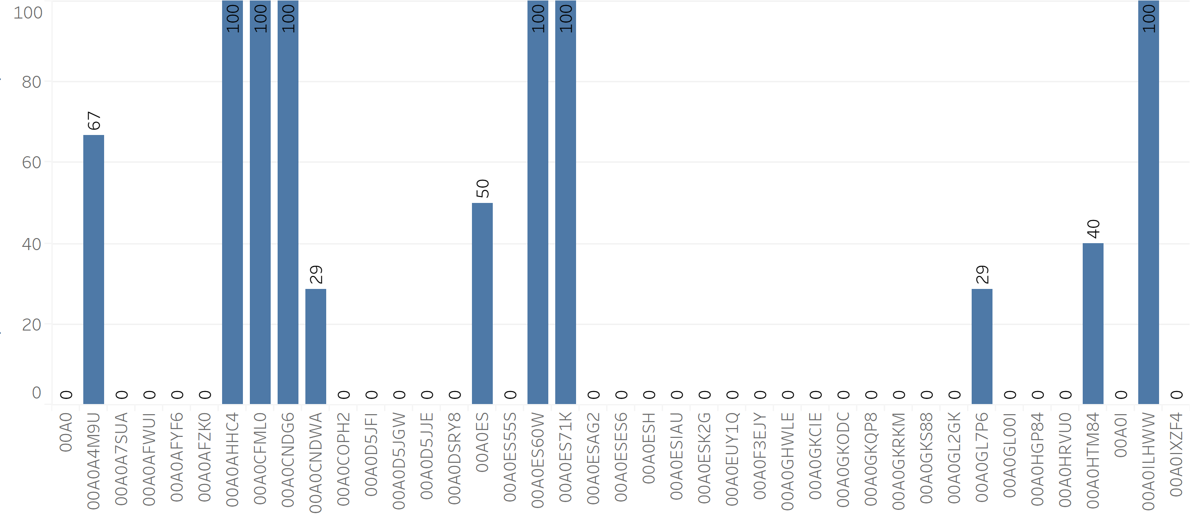

**Average of ratings and list of customers reviewed (Using Inner Join)**

If we want to join two outputs in one, we will use Inner Join. Here we want to concatenate average of rating and customers who reviewed that product in dataset.

So, we will use two mappers and one reducer to get separate outputs and then join them with Inner Join Method.

Here, we can see the product’s average rating and customers in one output making it convenient for product analysis.

**Outputs**

hadoop jar 8.RatingReviewJoin-1.0-SNAPSHOT.jar com.neu.edu.ratingreviewjoin.Driver /AmazonSports/Part5/result1 /AmazonSports/Part6/result6 /AmazonSports/Part8/result8

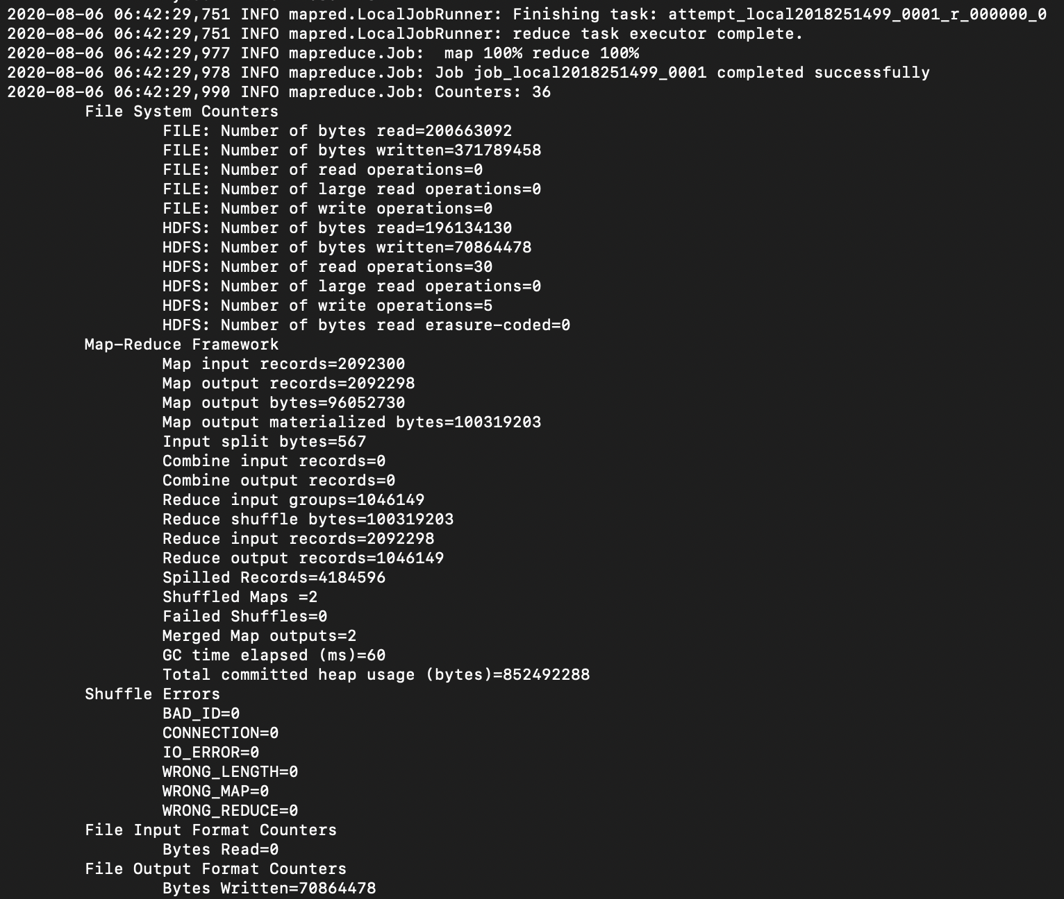



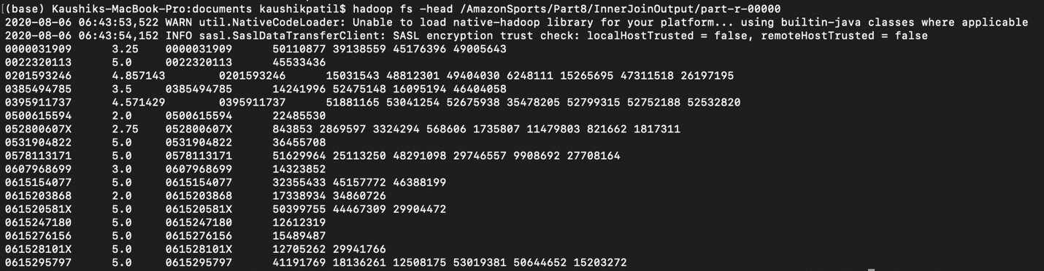

**Code**

**RatingReviewMapper1**

package com.neu.edu.ratingreviewjoin;

import java.io.IOException;

import org.apache.hadoop.io.LongWritable;

import org.apache.hadoop.io.Text;

import org.apache.hadoop.mapreduce.Mapper;

/**

*

* @author kaushikpatil

*/

public class RatingReviewMapper1 extends Mapper<LongWritable, Text, Text, Text> {

private Text k = new Text();

private Text v = new Text();

public void map(LongWritable key, Text value, Mapper.Context context) throws IOException, InterruptedException {

if (key.get() == 0) {

return;

}

String[] Input = value.toString().split("\\t");

String productid = Input[0].trim();

if (productid == null) {

return;

}

k.set(productid);

v.set("*" + value.toString());

context.write(k, v);

}

}

**RatingReviewMapper2**

package com.neu.edu.ratingreviewjoin;

import java.io.IOException;

import org.apache.hadoop.io.LongWritable;

import org.apache.hadoop.io.Text;

import org.apache.hadoop.mapreduce.Mapper;

/**

*

* @author kaushikpatil

*/

public class RatingReviewMapper2 extends Mapper<LongWritable, Text, Text, Text> {

private Text k = new Text();

private Text v = new Text();

public void map(LongWritable key, Text value, Mapper.Context context) throws IOException, InterruptedException {

if (key.get() == 0) {

return;

}

String[] Input = value.toString().split("\\t");

String productid = Input[0].trim();

if (productid == null) {

return;

}

k.set(productid);

v.set("#" + value.toString());

context.write(k, v);

}

}

**RatingReviewReducer**

package com.neu.edu.ratingreviewjoin;

import java.io.IOException;

import java.util.ArrayList;

import org.apache.hadoop.io.Text;

import org.apache.hadoop.mapreduce.Reducer;

/**

*

* @author kaushikpatil

*/

public class RatingReviewReducer extends Reducer<Text, Text, Text, Text> {

private static final Text EMPTY_TEXT = new Text("");

private Text tmp = new Text();

private ArrayList<Text> listA = new ArrayList<Text>();

private ArrayList<Text> listB = new ArrayList<Text>();

private String joinType = null;

public void setup(Reducer.Context context) {

joinType = context.getConfiguration().get("join.type");

}

public void reduce(Text key, Iterable<Text> values, Context context) throws IOException, InterruptedException {

listA.clear();

listB.clear();

while (values.iterator().hasNext()) {

tmp = values.iterator().next();

if (Character.toString((char) tmp.charAt(0)).equals("*")) {

listA.add(new Text(tmp.toString().substring(1)));

}

if (Character.toString((char) tmp.charAt(0)).equals("#")) {

listB.add(new Text(tmp.toString().substring(1)));

}

}

executeJoinLogic(context);

}

private void executeJoinLogic(Context context) throws IOException, InterruptedException {

if (joinType.equalsIgnoreCase("Inner")) {

if (!listA.isEmpty() && !listB.isEmpty()) {

for (Text A : listA) {

for (Text B : listB) {

context.write(A, B);

}

}

}

}

}

}

**Driver**

package com.neu.edu.ratingreviewjoin;

import java.io.IOException;

import org.apache.hadoop.conf.Configuration;

import org.apache.hadoop.fs.Path;

import org.apache.hadoop.io.Text;

import org.apache.hadoop.mapreduce.Job;

import org.apache.hadoop.mapreduce.lib.input.MultipleInputs;

import org.apache.hadoop.mapreduce.lib.input.TextInputFormat;

import org.apache.hadoop.mapreduce.lib.output.TextOutputFormat;

/**

*

* @author kaushikpatil

*/

public class Driver {

public static void main(String[] args) throws IOException, InterruptedException, ClassNotFoundException {

Configuration conf = new Configuration();

Job job = Job.getInstance(conf, "Inner Join");

job.setJarByClass(Driver.class);

MultipleInputs.addInputPath(job, new Path(args[0]), TextInputFormat.class, RatingReviewMapper1.class);

MultipleInputs.addInputPath(job, new Path(args[1]), TextInputFormat.class, RatingReviewMapper2.class);

job.getConfiguration().set("join.type", "Inner");

job.setReducerClass(RatingReviewReducer.class);

job.setOutputFormatClass(TextOutputFormat.class);

TextOutputFormat.setOutputPath(job, new Path(args[2]));

job.setOutputKeyClass(Text.class);

job.setOutputValueClass(Text.class);

System.exit(job.waitForCompletion(true) ? 0 : 2);

}

}

**Amazon Word Count**

We are implementing this analysis for getting the word frequency i.e. the number of times the word has occurred in the review. This helps in knowing that particular review is positive, negative or neutral.

**Outputs**

hadoop jar 9.WordCount-1.0-SNAPSHOT.jar com.neu.edu.wordcount.Driver /AmazonSports/amazon_reviews_us_Sports_v1_00.tsv /AmazonSports/Part9/result9

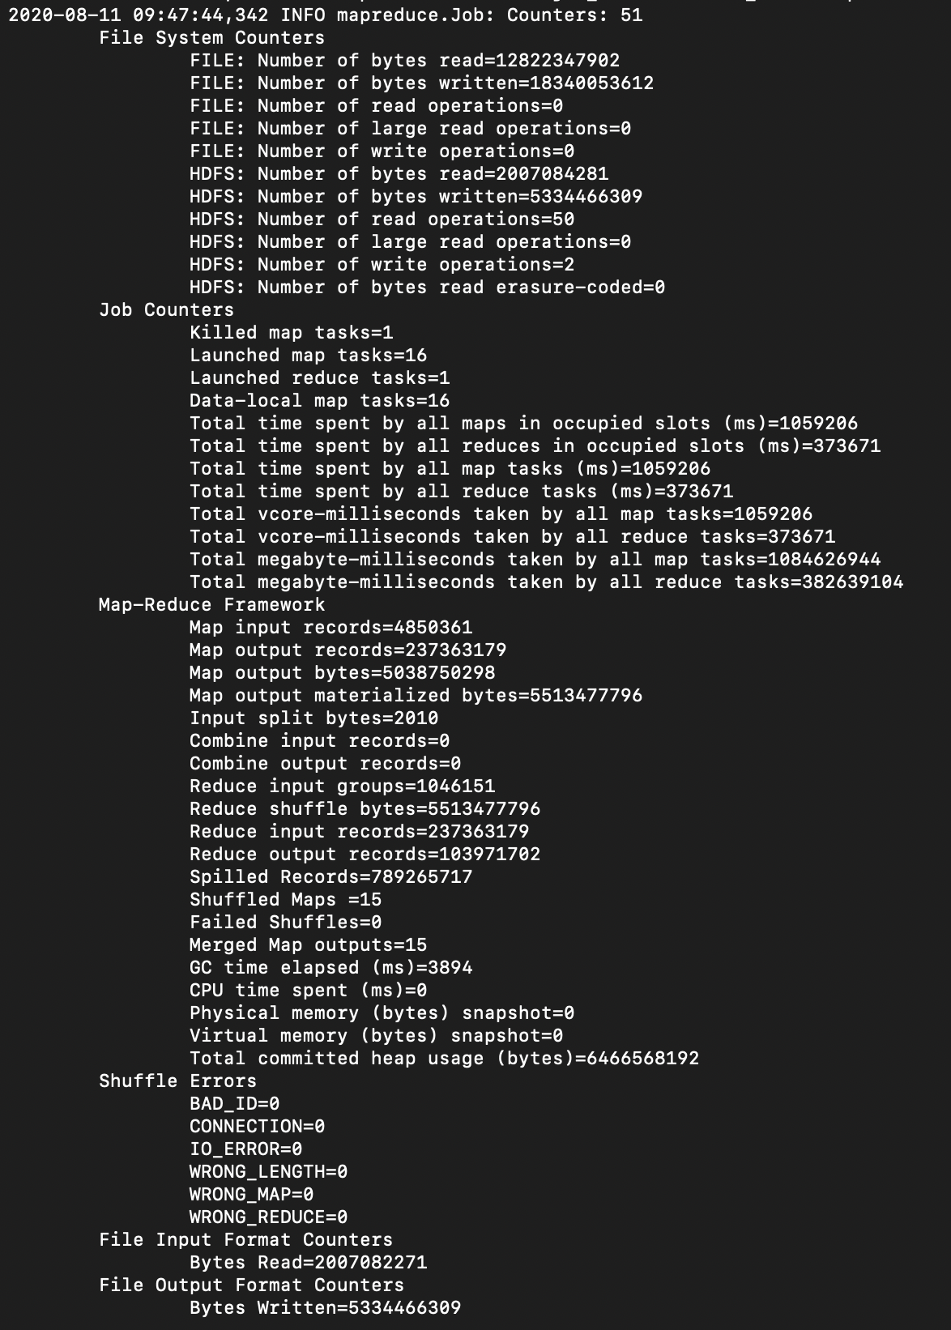

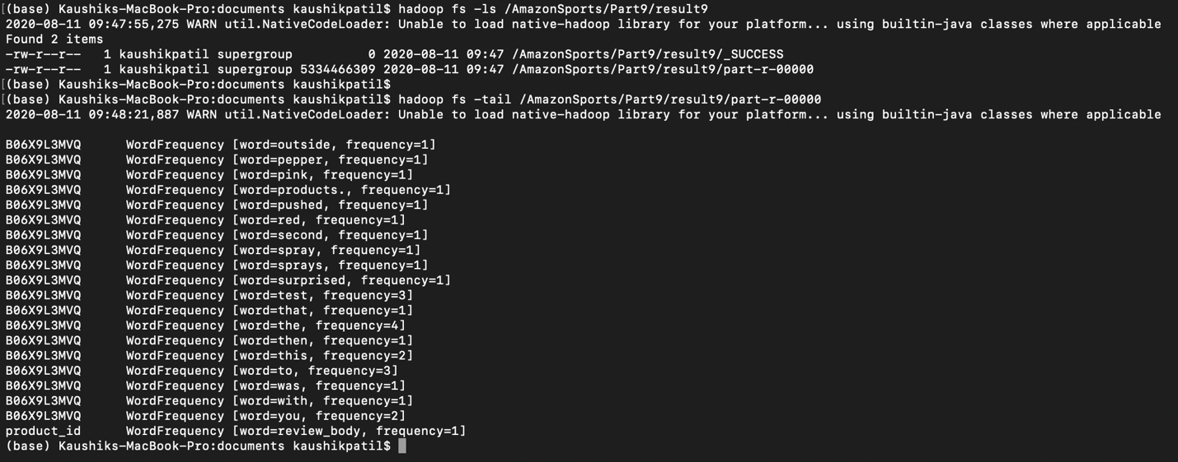

**Code**

**WordCountMapper**

package com.neu.edu.wordcount;

import java.io.IOException;

import java.util.Arrays;

import java.util.HashSet;

import java.util.Set;

import org.apache.hadoop.io.Text;

import org.apache.hadoop.mapreduce.Mapper;

/**

*

* @author kaushikpatil

*/

public class WordCountMapper extends Mapper<Object,Text,Text,WordFrequency>{

@Override

protected void map(Object key, Text value, Context context) throws IOException,

InterruptedException {

String values[] = value.toString().split("\t");

String product = values[3].toString();

String review = values[13].toString();

Text prod = new Text();

prod.set(product);

for(String str : review.split(" ")) {

WordFrequency wf = new WordFrequency(1, str);

context.write(prod,wf);

}

}

}

**WordCountReducer**

package com.neu.edu.wordcount;

import java.io.IOException;

import java.util.Map;

import java.util.TreeMap;

import org.apache.hadoop.io.Text;

import org.apache.hadoop.mapreduce.Reducer;

/**

*

* @author kaushikpatil

*/

public class WordCountReducer extends Reducer<Text, WordFrequency, Text,WordFrequency>{

@Override

protected void reduce(Text key, Iterable<WordFrequency> values, Context context) throws IOException, InterruptedException {

Map<String, Integer> frequencyMap = new TreeMap<String,Integer>();

for(WordFrequency wf : values) {

if(!frequencyMap.containsKey(wf.getWord())) {

frequencyMap.put(wf.getWord(), wf.getFrequency());

}

else {

int freq = frequencyMap.get(wf.getWord());

frequencyMap.put(wf.getWord(), freq + 1);

}

}

for(Map.Entry<String, Integer> entry : frequencyMap.entrySet()) {

WordFrequency wf1 = new WordFrequency();

wf1.setFrequency(entry.getValue());

wf1.setWord(entry.getKey());

context.write(key, wf1);

}

}

}

**WordFrequency**

package com.neu.edu.wordcount;

import java.io.DataInput;

import java.io.DataOutput;

import java.io.IOException;

import org.apache.hadoop.io.Writable;

import org.apache.hadoop.io.WritableComparable;

/**

*

* @author kaushikpatil

*/

public class WordFrequency implements Writable, WritableComparable<WordFrequency>{

private String word;

private int frequency;

public WordFrequency() {

super();

}

public WordFrequency(int frequency, String word) {

super();

this.frequency = frequency;

this.word = word;

}

@Override

public String toString() {

return "WordFrequency [word=" + word + ", frequency=" + frequency + "]";

}

public String getWord() {

return word;

}

public void setWord(String word) {

this.word = word;

}

public int getFrequency() {

return frequency;

}

public void setFrequency(int frequency) {

this.frequency = frequency;

}

@Override

public int hashCode() {

final int prime = 31;

int result = 1;

result = prime * result + frequency;

result = prime * result + ((word == null) ? 0 : word.hashCode());

return result;

}

@Override

public boolean equals(Object obj) {

if (this == obj)

return true;

if (obj == null)

return false;

if (getClass() != obj.getClass())

return false;

WordFrequency other = (WordFrequency) obj;

if (frequency != other.frequency)

return false;

if (word == null) {

if (other.word != null)

return false;

} else if (!word.equals(other.word))

return false;

return true;

}

public void readFields(DataInput in) throws IOException {

frequency = in.readInt();

word = in.readUTF();

}

public void write(DataOutput out) throws IOException {

out.writeInt(frequency);

out.writeUTF(word);

}

public int compareTo(WordFrequency o) {

int result = -1;

if(frequency > o.frequency) {

result = 1;

}

if(frequency == o.frequency) {

result = 0;

}

if(result == 0) {

result = word.compareTo(o.word);

}

return result;

}

}

**Driver**

package com.neu.edu.wordcount;

import org.apache.hadoop.conf.Configuration;

import org.apache.hadoop.fs.FileSystem;

import org.apache.hadoop.fs.Path;

import org.apache.hadoop.io.Text;

import org.apache.hadoop.mapreduce.Job;

import org.apache.hadoop.mapreduce.lib.input.FileInputFormat;

import org.apache.hadoop.mapreduce.lib.input.TextInputFormat;

import org.apache.hadoop.mapreduce.lib.output.FileOutputFormat;

/**

*

* @author kaushikpatil

*/

public class Driver {

public static void main(String[] args) throws Exception {

if (args.length != 2) {

System.err.println("Usage: MaxSubmittedCharge <input path> <output path>");

System.exit(-1);

}

Path inputPath = new Path(args[0]);

Path outputDir = new Path(args[1]);

Configuration conf = new Configuration(true);

Job job = Job.getInstance(conf);

job.setJarByClass(WordCountMapper.class);

job.setMapperClass(WordCountMapper.class);

job.setReducerClass(WordCountReducer.class);

job.setNumReduceTasks(1);

job.setMapOutputKeyClass(Text.class);

job.setMapOutputValueClass(WordFrequency.class);

job.setOutputKeyClass(Text.class);

job.setOutputValueClass(WordFrequency.class);

FileInputFormat.addInputPath(job, inputPath);

job.setInputFormatClass(TextInputFormat.class);

FileOutputFormat.setOutputPath(job, outputDir);

FileSystem hdfs = FileSystem.get(conf);

if (hdfs.exists(outputDir)) {

hdfs.delete(outputDir, true);

}

int code = job.waitForCompletion(true) ? 0 : 1;

System.exit(code);

}

}

**Stemmer**

package com.neu.edu.wordcount;

class Stemmer

{ private char[] b;

private int i, /* offset into b */

i_end, /* offset to end of stemmed word */

j, k;

private static final int INC = 50;

/* unit of size whereby b is increased */

public Stemmer()

{ b = new char[INC];

i = 0;

i_end = 0;

}

/**

* Add a character to the word being stemmed. When you are finished

* adding characters, you can call stem(void) to stem the word.

*/

public void add(char ch)

{ if (i == b.length)

{ char[] new_b = new char[i+INC];

for (int c = 0; c < i; c++) new_b[c] = b[c];

b = new_b;

}

b[i++] = ch;

}

/** Adds wLen characters to the word being stemmed contained in a portion

* of a char[] array. This is like repeated calls of add(char ch), but

* faster.

*/

public void add(char[] w, int wLen)

{ if (i+wLen >= b.length)

{ char[] new_b = new char[i+wLen+INC];

for (int c = 0; c < i; c++) new_b[c] = b[c];

b = new_b;

}

for (int c = 0; c < wLen; c++) b[i++] = w[c];

}

/**

* After a word has been stemmed, it can be retrieved by toString(),

* or a reference to the internal buffer can be retrieved by getResultBuffer

* and getResultLength (which is generally more efficient.)

*/

public String toString() { return new String(b,0,i_end); }

/**

* Returns the length of the word resulting from the stemming process.

*/

public int getResultLength() { return i_end; }

/**

* Returns a reference to a character buffer containing the results of

* the stemming process. You also need to consult getResultLength()

* to determine the length of the result.

*/

public char[] getResultBuffer() { return b; }

/* cons(i) is true <=> b[i] is a consonant. */

private final boolean cons(int i)

{ switch (b[i])

{ case 'a': case 'e': case 'i': case 'o': case 'u': return false;

case 'y': return (i==0) ? true : !cons(i-1);

default: return true;

}

}

/* m() measures the number of consonant sequences between 0 and j. if c is

a consonant sequence and v a vowel sequence, and <..> indicates arbitrary

presence,

<c><v> gives 0

<c>vc<v> gives 1

<c>vcvc<v> gives 2

<c>vcvcvc<v> gives 3

....

*/

private final int m()

{ int n = 0;

int i = 0;

while(true)

{ if (i > j) return n;

if (! cons(i)) break; i++;

}

i++;

while(true)

{ while(true)

{ if (i > j) return n;

if (cons(i)) break;

i++;

}

i++;

n++;

while(true)

{ if (i > j) return n;

if (! cons(i)) break;

i++;

}

i++;

}

}

/* vowelinstem() is true <=> 0,...j contains a vowel */

private final boolean vowelinstem()

{ int i; for (i = 0; i <= j; i++) if (! cons(i)) return true;

return false;

}

/* doublec(j) is true <=> j,(j-1) contain a double consonant. */

private final boolean doublec(int j)

{ if (j < 1) return false;

if (b[j] != b[j-1]) return false;

return cons(j);

}

/* cvc(i) is true <=> i-2,i-1,i has the form consonant - vowel - consonant

and also if the second c is not w,x or y. this is used when trying to

restore an e at the end of a short word. e.g.

cav(e), lov(e), hop(e), crim(e), but

snow, box, tray.

*/

private final boolean cvc(int i)

{ if (i < 2 || !cons(i) || cons(i-1) || !cons(i-2)) return false;

{ int ch = b[i];

if (ch == 'w' || ch == 'x' || ch == 'y') return false;

}

return true;

}

private final boolean ends(String s)

{ int l = s.length();

int o = k-l+1;

if (o < 0) return false;

for (int i = 0; i < l; i++) if (b[o+i] != s.charAt(i)) return false;

j = k-l;

return true;

}

/* setto(s) sets (j+1),...k to the characters in the string s, readjusting

k. */

private final void setto(String s)

{ int l = s.length();

int o = j+1;

for (int i = 0; i < l; i++) b[o+i] = s.charAt(i);

k = j+l;

}

/* r(s) is used further down. */

private final void r(String s) { if (m() > 0) setto(s); }

/* step1() gets rid of plurals and -ed or -ing. e.g.

caresses -> caress

ponies -> poni

ties -> ti

caress -> caress

cats -> cat

feed -> feed

agreed -> agree

disabled -> disable

matting -> mat

mating -> mate

meeting -> meet

milling -> mill

messing -> mess

meetings -> meet

*/

private final void step1()

{ if (b[k] == 's')

{ if (ends("sses")) k -= 2; else

if (ends("ies")) setto("i"); else

if (b[k-1] != 's') k--;

}

if (ends("eed")) { if (m() > 0) k--; } else

if ((ends("ed") || ends("ing")) && vowelinstem())

{ k = j;

if (ends("at")) setto("ate"); else

if (ends("bl")) setto("ble"); else

if (ends("iz")) setto("ize"); else

if (doublec(k))

{ k--;

{ int ch = b[k];

if (ch == 'l' || ch == 's' || ch == 'z') k++;

}

}

else if (m() == 1 && cvc(k)) setto("e");

}

}

/* step2() turns terminal y to i when there is another vowel in the stem. */

private final void step2() { if (ends("y") && vowelinstem()) b[k] = 'i'; }

/* step3() maps double suffices to single ones. so -ization ( = -ize plus

-ation) maps to -ize etc. note that the string before the suffix must give

m() > 0. */

private final void step3() { if (k == 0) return; /* For Bug 1 */ switch (b[k-1])

{

case 'a': if (ends("ational")) { r("ate"); break; }

if (ends("tional")) { r("tion"); break; }

break;

case 'c': if (ends("enci")) { r("ence"); break; }

if (ends("anci")) { r("ance"); break; }

break;

case 'e': if (ends("izer")) { r("ize"); break; }

break;

case 'l': if (ends("bli")) { r("ble"); break; }

if (ends("alli")) { r("al"); break; }

if (ends("entli")) { r("ent"); break; }

if (ends("eli")) { r("e"); break; }

if (ends("ousli")) { r("ous"); break; }

break;

case 'o': if (ends("ization")) { r("ize"); break; }

if (ends("ation")) { r("ate"); break; }

if (ends("ator")) { r("ate"); break; }

break;

case 's': if (ends("alism")) { r("al"); break; }

if (ends("iveness")) { r("ive"); break; }

if (ends("fulness")) { r("ful"); break; }

if (ends("ousness")) { r("ous"); break; }

break;

case 't': if (ends("aliti")) { r("al"); break; }

if (ends("iviti")) { r("ive"); break; }

if (ends("biliti")) { r("ble"); break; }

break;

case 'g': if (ends("logi")) { r("log"); break; }

} }

/* step4() deals with -ic-, -full, -ness etc. similar strategy to step3. */

private final void step4() { switch (b[k])

{

case 'e': if (ends("icate")) { r("ic"); break; }

if (ends("ative")) { r(""); break; }

if (ends("alize")) { r("al"); break; }

break;

case 'i': if (ends("iciti")) { r("ic"); break; }

break;

case 'l': if (ends("ical")) { r("ic"); break; }

if (ends("ful")) { r(""); break; }

break;

case 's': if (ends("ness")) { r(""); break; }

break;

} }

/* step5() takes off -ant, -ence etc., in context <c>vcvc<v>. */

private final void step5()

{ if (k == 0) return; /* for Bug 1 */ switch (b[k-1])

{ case 'a': if (ends("al")) break; return;

case 'c': if (ends("ance")) break;

if (ends("ence")) break; return;

case 'e': if (ends("er")) break; return;

case 'i': if (ends("ic")) break; return;

case 'l': if (ends("able")) break;

if (ends("ible")) break; return;

case 'n': if (ends("ant")) break;

if (ends("ement")) break;

if (ends("ment")) break;

/* element etc. not stripped before the m */

if (ends("ent")) break; return;

case 'o': if (ends("ion") && j >= 0 && (b[j] == 's' || b[j] == 't')) break;

/* j >= 0 fixes Bug 2 */

if (ends("ou")) break; return;

/* takes care of -ous */

case 's': if (ends("ism")) break; return;

case 't': if (ends("ate")) break;

if (ends("iti")) break; return;

case 'u': if (ends("ous")) break; return;

case 'v': if (ends("ive")) break; return;

case 'z': if (ends("ize")) break; return;

default: return;

}

if (m() > 1) k = j;

}

/* step6() removes a final -e if m() > 1. */

private final void step6()

{ j = k;

if (b[k] == 'e')

{ int a = m();

if (a > 1 || a == 1 && !cvc(k-1)) k--;

}

if (b[k] == 'l' && doublec(k) && m() > 1) k--;

}

/** Stem the word placed into the Stemmer buffer through calls to add().

* Returns true if the stemming process resulted in a word different

* from the input. You can retrieve the result with

* getResultLength()/getResultBuffer() or toString().

*/

public void stem()

{ k = i - 1;

if (k > 1) { step1(); step2(); step3(); step4(); step5(); step6(); }

i_end = k+1; i = 0;

}

public String stem(String s) {

for(char c : s.toCharArray()) {

add(c);

}

stem();

return toString();

}

}

**Stopwords**

package com.neu.edu.wordcount;

import java.util.HashSet;

import java.util.Set;

import java.util.Arrays;

/**

*

* @author kaushikpatil

*/

public class Stopwords {

public static String[] stopwords = {"B06X9L3MVQ"};

public static Set<String> stopWordSet = new HashSet<String>(Arrays.asList(stopwords));

public static Set<String> stemmedStopWordSet = stemStringSet(stopWordSet);

public static boolean isStopword(String word) {

if(word.length() < 2) return true;

if(word.charAt(0) >= '0' && word.charAt(0) <= '9')

return true; //remove numbers, "25th", etc

if(stopWordSet.contains(word)) return true;

else return false;

}

public static boolean isStemmedStopword(String word) {

if(word.length() < 2) return true;

if(word.charAt(0) >= '0' && word.charAt(0) <= '9') return true; //remove numbers, "25th", etc

String stemmed = stemString(word);

if(stopWordSet.contains(stemmed))

return true;

if(stemmedStopWordSet.contains(stemmed))

return true;

if(stopWordSet.contains(word))

return true;

if(stemmedStopWordSet.contains(word))

return true;

else

return false;

}

public static String removeStopWords(String string) {

String result = "";

String[] words = string.split("\\s+");

for(String word : words) {

if(word.isEmpty()) continue;

if(isStopword(string)) continue; //remove stopwords

result += (word+" ");

}

return result;

}

public static String removeStemmedStopWords(String string) {

String result = "";

String[] words = string.split("\\s+");

for(String word : words) {

if(word.isEmpty()) continue;

if(isStemmedStopword(word)) continue;

if(word.charAt(0) >= '0' && word.charAt(0) <= '9') continue; //remove numbers, "25th", etc

result += (word+" ");

}

return result;

}

public static String stemString(String string) {

return new Stemmer().stem(string);

}

public static Set<String> stemStringSet(Set<String> stringSet) {

Stemmer stemmer = new Stemmer();

Set<String> results = new HashSet<String>();

for(String string : stringSet) {

results.add(stemmer.stem(string));

}

return results;

}

}

**Data Visualization**

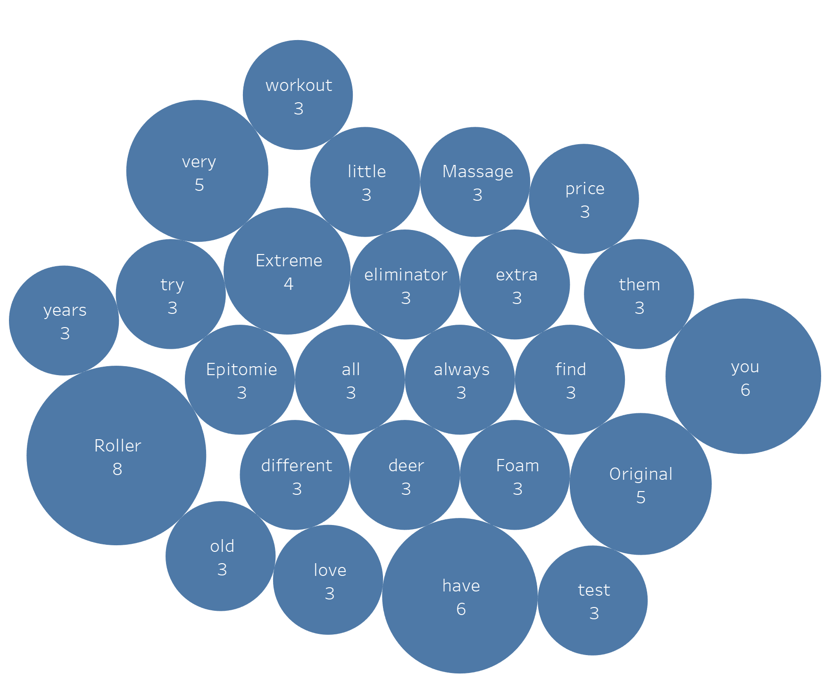

**Hive**

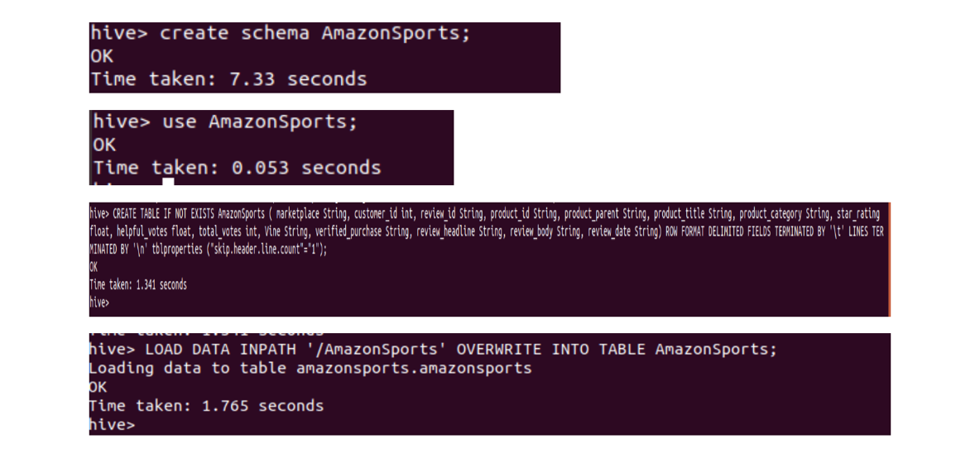

CREATE TABLE IF NOT EXISTS AmazonSports (

marketplace String,

customer_id int,

review_id String,

product_id String,

product_parent String,

product_title String,

product_category String,

star_rating float,

helpful_votes float,

total_votes int,

Vine String,

verified_purchase String,

review_headline String,

review_body String,

review_date String)

ROW FORMAT DELIMITED FIELDS TERMINATED BY ‘\t’ _LINES TERMINATED BY ‘\n’

tblproperties ("skip.header.line.count"="1");

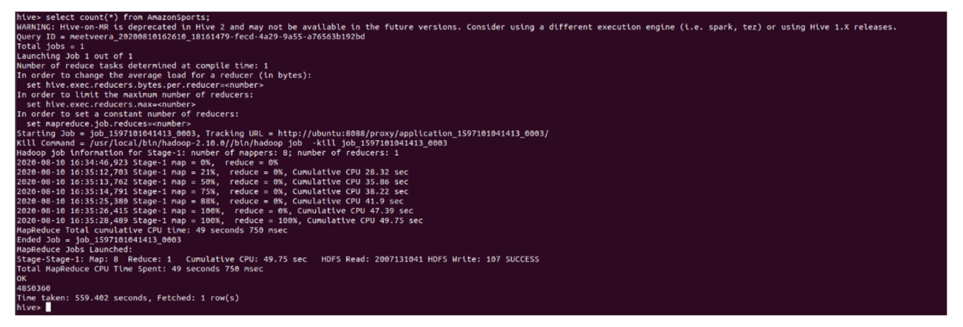

**Top 10 Best Products based on average ratings**

Select product_id, avg(star_rating) as ProdAverage

From AmazonSports

group by Product_ID

order by ProdAverage DESC limit 10;

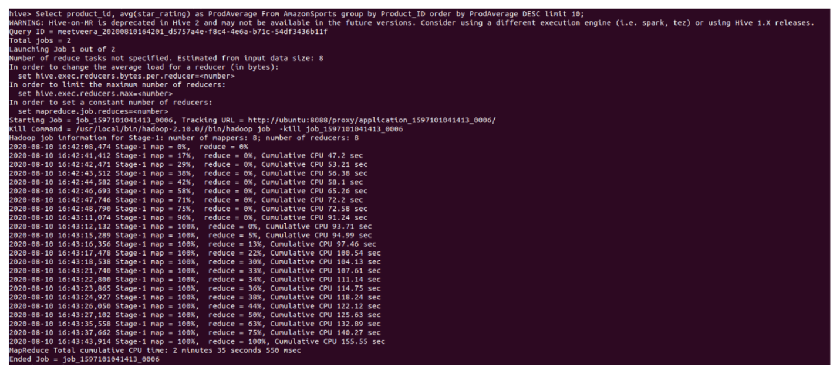

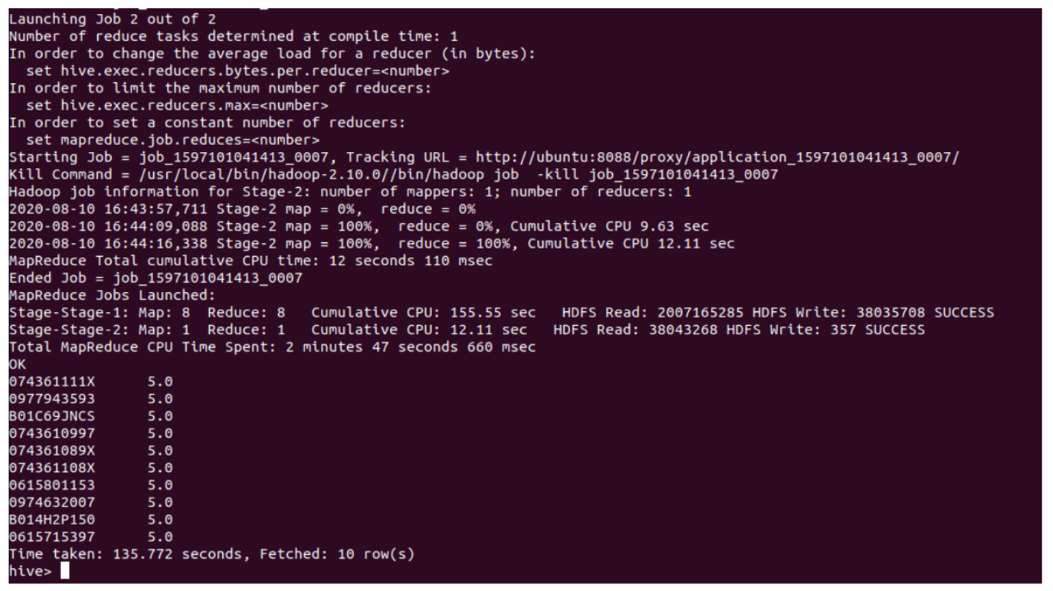

**Top 3 Customer based on the number of products**

select customer_id, count(product_id) as totalProducts

from AmazonSports

group by customer_id

order by totalProducts desc limit 3;

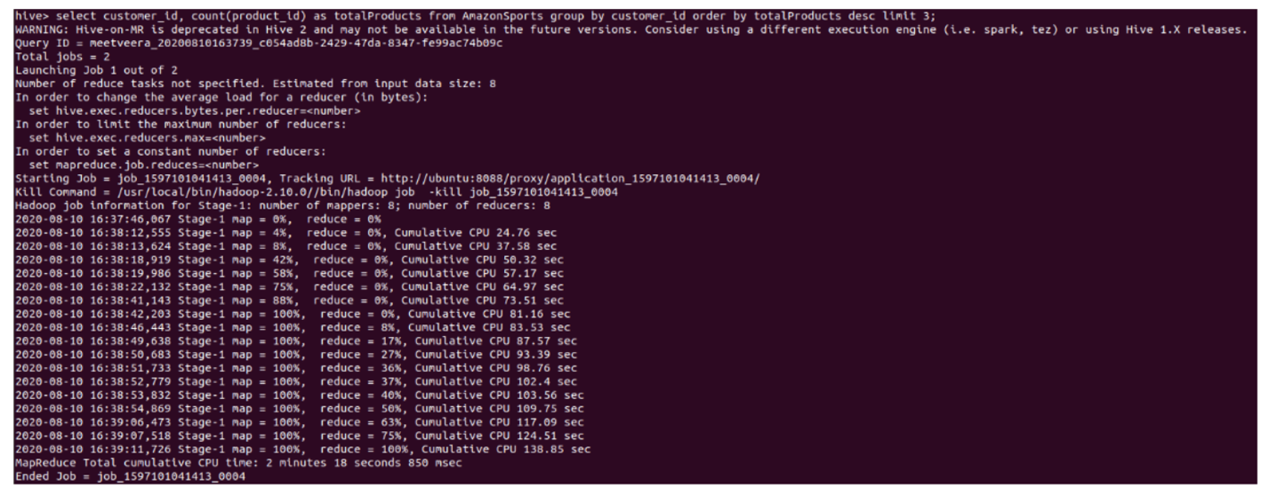

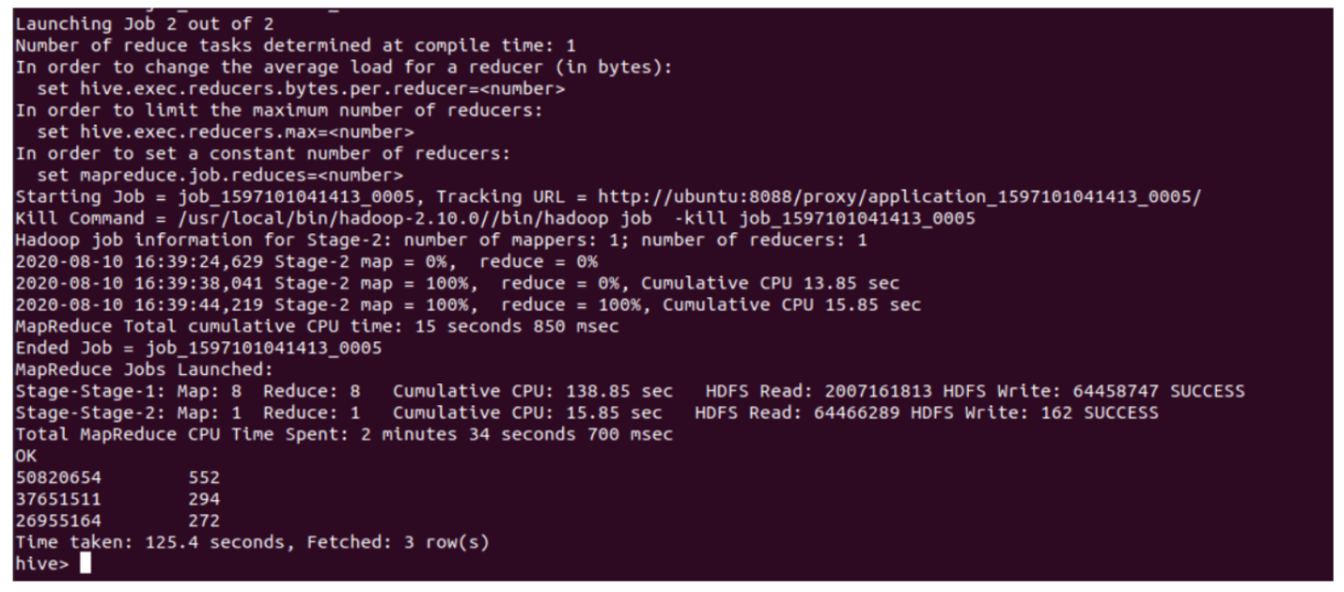

**Top 3 Popular Product based on number of products sold**

select product_id, count(product_id) as numberofprods

from AmazonSports

group by product_id

order by numberofprods desc limit 3;

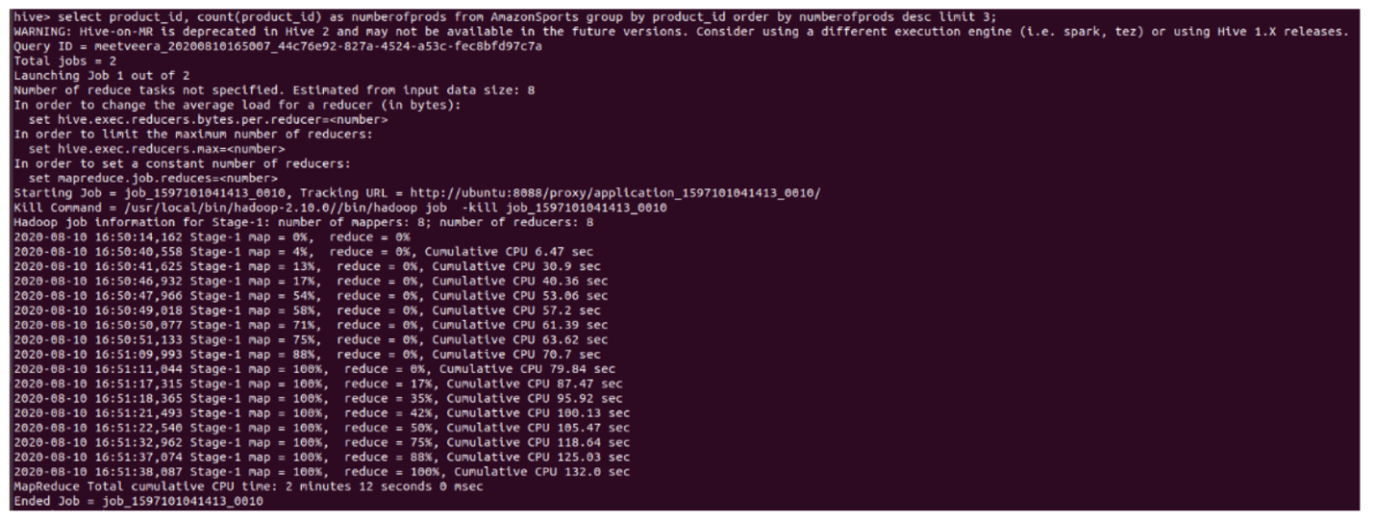

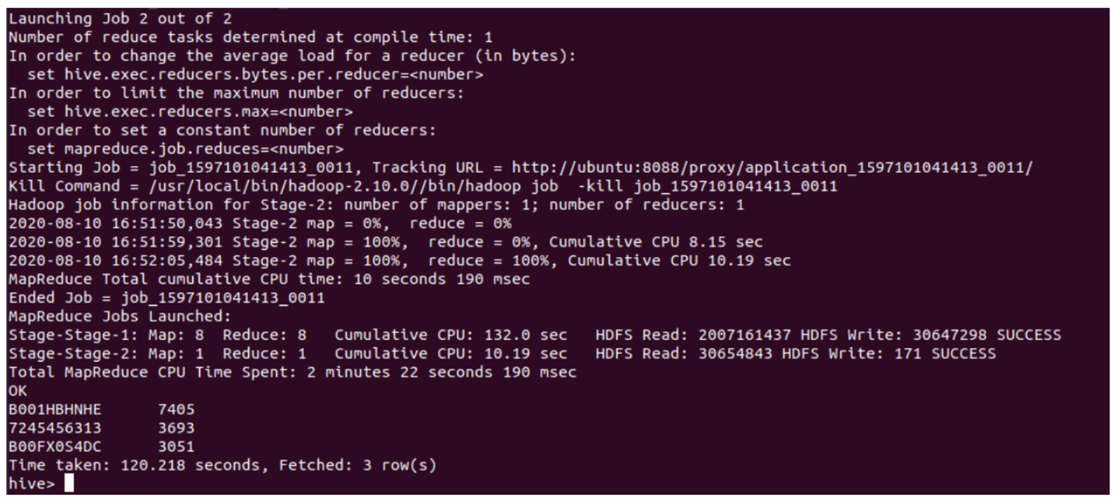

**Number of products sold per day**

Select review_date , count(product_id) as ProductsInDays

from AmazonSports

group by review_date

order by ProductsInDays desc limit 10;

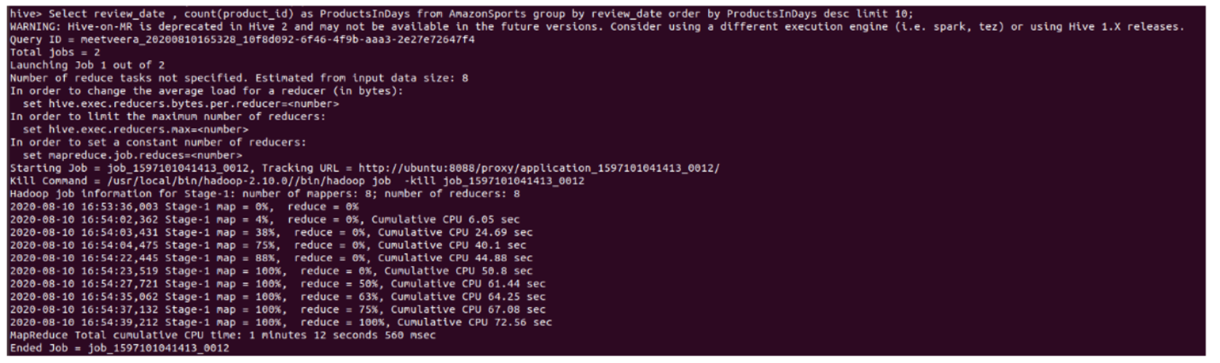

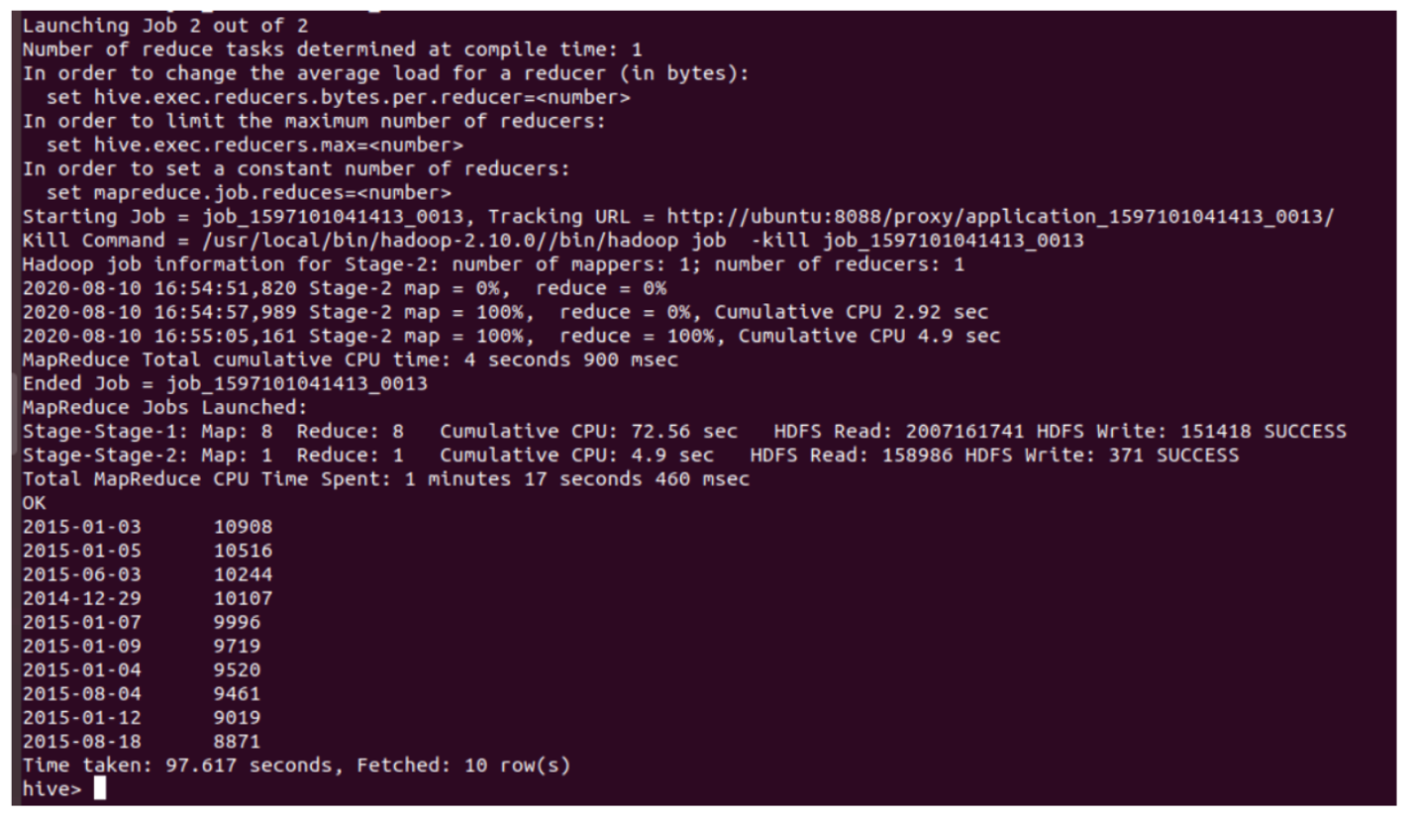

**Number of products per rating**

select star_rating, count(product_id) as ProductsInRating

from AmazonSports

group by star_rating

order by ProductsInRating desc limit 5;

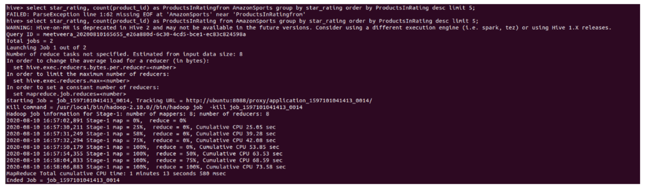

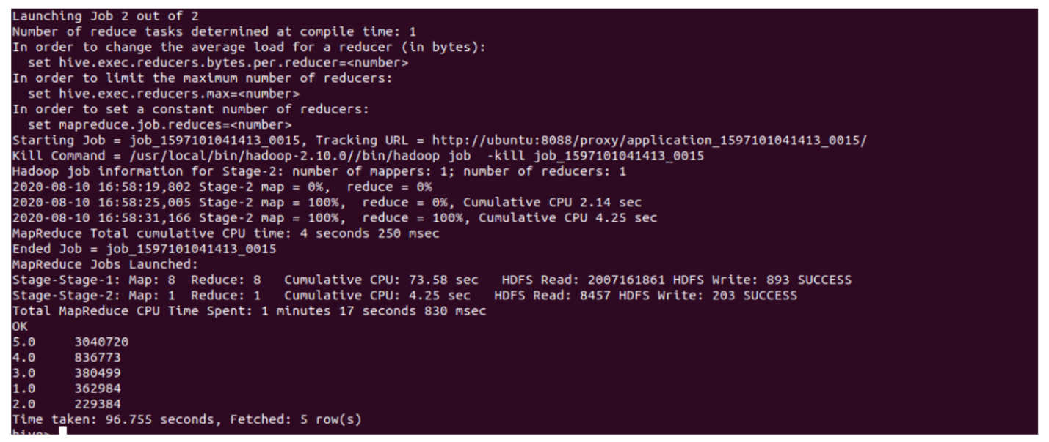

**Pig**

data1 = load '/user/hadoop/AmazonSports.tsv' using PigStorage('\t') AS (marketplace, customer_id, review_id, product_id, product_parent, product_title, product_category, star_rating, helpful_votes, total_votes, vine, verified_purchase, review_headline, review_body, review_date);

**Count of Daily Reviews**

dailydata = GROUP data by review_date;

daily_reviews = FOREACH dailydata GENERATE group as review_date, COUNT(data.review_id) as count;

orderdata = ORDER daily_reviews BY count DESC;

store orderdata INTO '/pig1';

hadoop fs -ls /pig1

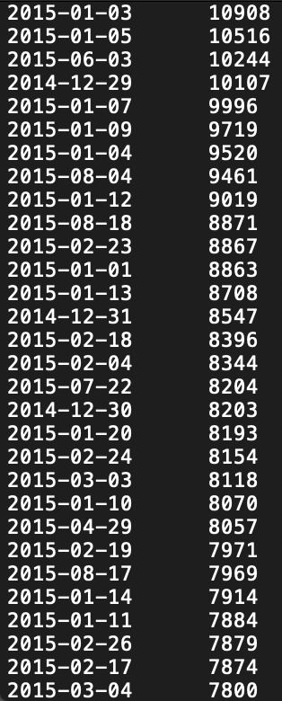

**Reviews per Rating**

product = GROUP data by star_rating;

prod_count = FOREACH product GENERATE group as star_rating, COUNT (data.product_id) as count;

store prod_count INTO '/pig2';

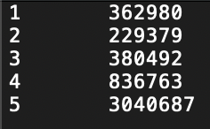

**Conclusion**

**Hence, we have successfully implemented all the deliverables in Amazon Sports Reviews Data Analysis using Big Data Tools such as Hadoop MapReduce, Apache Hive and Apache Pig along with some data visualization using Tableau.**

**--------------------x---------------------**